**Car Service Management System**

**A Project Report**

Submitted in partial fulfillment of the

Requirements for the award of the Degree of

**BACHELOR OF SCIENCE (INFORMATION TECHNOLOGY)**

**By**

Rahul Singh

17067

**Under the esteemed guidance of**

**Mr. Manish Karale**

**I.T. Coordinator**



**DEPARTMENT OF INFORMATION TECHNOLOGY**

**R. D. NATIONAL & W. A. SCIENCE COLLEGE**

***(Affiliated to University of Mumbai)***

**MUMBAI, 400050**

**MAHARASHTRA**

**2020**

**R. D. NATIONAL & W. A. SCIENCE COLLEGE**

***(Affiliated to University of Mumbai)***

**MUMBAI – MAHARASHTRA - 400050**

**DEPARTMENT OF INFORMATION TECHNOLOGY**



**CERTIFICATE**

This is to certify that the project entitled, **“Car Service Management System"**, is bonafiedwork of **Rahul Singh** bearing Seat. No: **(17067)** submitted in partialfulfillment of the requirements for the award of degree of BACHELOR OF SCIENCE in INFORMATION TECHNOLOGY from University of Mumbai.

**Internal Guide Coordinator**

**External Examiner**

**Date: ___________ College Seal**

**ACKNOWLEDGEMENT**

We take this opportunity to express our gratitude to the department of BSc.IT for nurturing and teaching us the nuances required for developing this project. Our head of Department **Mr. Dinesh Himatsinghani** has been very helpful for making all facilities available to us. He always had a watchful eye on our progress throughout the project.

We are immensely thankful to our professor **Mr. Manish Karale** for his valuable and time inputs.

Once again we are grateful to our guide **Mrs. Manisha Suthar** without whom this project would be impossible. She was not only our guide but our source of inspiration. She was always available and patient with us in our times of need and we owe her our greatest appreciation.

We consider ourselves fortunate to have got an opportunity of working for **Car Service Management System**. Her vast details in the concerned field allowed us to incorporate the minute details of the subject in our project. She made us feel comfortable at all times with her kind words and encouragement. We would like to thank her dedicating some of his time from her schedule, to help us in our project with a stoical attitude.

Last but not the least our heartfelt gratitude to the **Staff Members** both at **R.D. National College** and **Car Service Management System**. for their corporation and support.

This project was a great learning and humbling experience and reflects our academic work at National College. We are sure that this experience will hold us good stead when we begin our professional careers.

**Abstract**

Objective:-

This system **“Car service management system (CSMS)”** allows providing Car for service. If customer got any problem with his Car they are providing services

The real power of this project lies not in direct selling of products, but in the creation of tighter relationships with customers and delivering of a high level of service and support, which in turn improves organization sales and its goodwill. A service organization is a business entity that takes care of servicing a customer instrument in the after sales domain.

**This project contains 2 modules namely :-**

* **User Module**,
* **Admin Module,**

**Content**

* **Analysis**
* **Design**
* **Use case Diagram**
* **Sequence Diagram**
* **Class Diagram**
* **Data flow diagram**
* **ER Diagram**
* **Database Design**
* **Modules**
* **Feasibility Study**
* **Implementation**
* **Testing**
* **Output Screen**
* **Conclusion**
* **References**

**Analysis**

**SYSTEM ANALYSIS**:

1. Existing System

Existing system is a manual one in which users are maintaining books to store the information like product details, Distributors details, purchases, sales details and accounts for every month. It is very difficult to maintain historical data.

The following are the disadvantages of the existing system

* It is difficult to maintain important information in books.
* More manual hours need to generate required reports.
* It is tedious to manage historical data which needs much space to keep all the previous years’ ledgers, books etc.
* Daily sales and purchases details must be entered into books are very difficult to maintain.

2. Proposed System

The DISTRIBUTORS MANAGEMENT TOOL is a software application which avoids more manual hours that need to spend in record keeping and generating reports. This application keeps the data in a centralized way which is available to all the users simultaneously. It is very easy to manage historical data in database. No specific training is required for the distributors to use this application. They can easily use the tool that decreases manual hours spending for normal things and hence increases the performance. It is very easy to record the information of online sales and purchases in the databases.

3. Objective of the System

The objective of the Car Services is to provide better information for the users of this system for better results for their maintenance in the product details that is sales, purchases and stock.

**System Specifications**

Hardware Requirements:-

* Pentium-IV(Processor).
* 256 MB Ram
* 512 KB Cache Memory
* Hard disk 10 GB
* Microsoft Compatible 101 or more Key Board

Software Requirements: -

* **Operating System :** Windows / Linux any one
* **Programming language:** PHP
* **Web-Technology:** Open Source
* **Front-End:** PHP
* **Back-End:** MySQL
* **Web Server:** Apache

**Design**

INTRODUCTION:

Design is the first step in the development phase for any techniques and principles for the purpose of defining a device, a process or system in sufficient detail to permit its physical realization.

Once the software requirements have been analyzed and specified the software design involves three technical activities - design, coding, implementation and testing that are required to build and verify the software.

The design activities are of main importance in this phase, because in this activity, decisions ultimately affecting the success of the software implementation and its ease of maintenance are made. These decisions have the final bearing upon reliability and maintainability of the system. Design is the only way to accurately translate the customer’s requirements into finished software or a system.

Design is the place where quality is fostered in development. Software design is a process through which requirements are translated into a representation of software. Software design is conducted in two steps. Preliminary design is concerned with the transformation of requirements into data.

UML Diagrams:

Actor:  
 A coherent set of roles that users of use cases play when interacting with the use `cases.

Use case:

A description of sequence of actions, including variants, that a system performs that yields an observable result of value of an actor.



UML stands for Unified Modeling Language. UML is a language for specifying, visualizing and documenting the system. This is the step while developing any product after analysis. The goal from this is to produce a model of the entities involved in the project which later need to be built. The representation of the entities that are to be used in the product being developed need to be designed.

There are various kinds of methods in software design:

They are as follows:

* Use case Diagram
* Sequence Diagram
* Collaboration Diagram
* Activity Diagram
* State chat Diagram

**USECASE DIAGRAMS:**

Use case diagrams model behavior within a system and helps the developers understand of what the user require. The stick man represents what’s called an actor.

Use case diagram can be useful for getting an overall view of the system and clarifying who can do and more importantly what they can’t do.

Use case diagram consists of use cases and actors and shows the interaction between the use case and actors.

* The purpose is to show the interactions between the use case and actor.
* To represent the system requirements from user’s perspective.
* An actor could be the end-user of the system or an external system.

**USECASE DIAGRAM:**

A Use case is a description of set of sequence of actions. Graphically it is rendered as an ellipse with solid line including only its name. Use case diagram is a behavioral diagram that shows a set of use cases and actors and their relationship. It is an association between the use cases and actors. An actor represents a real-world object. Primary Actor – Sender, Secondary Actor Receiver.

**User (Customer) USE CASE DIAGRAM:**

**Admin USE CASE DIAGRAM:**

**SEQUENCE DIAGRAM:**

Sequence diagram and collaboration diagram are called INTERACTION DIAGRAMS. An interaction diagram shows an interaction, consisting of set of objects and their relationship including the messages that may be dispatched among them.

A sequence diagram is an introduction that empathizes the time ordering of messages. Graphically a sequence diagram is a table that shows objects arranged along the X-axis and messages ordered in increasing time along the Y- axis

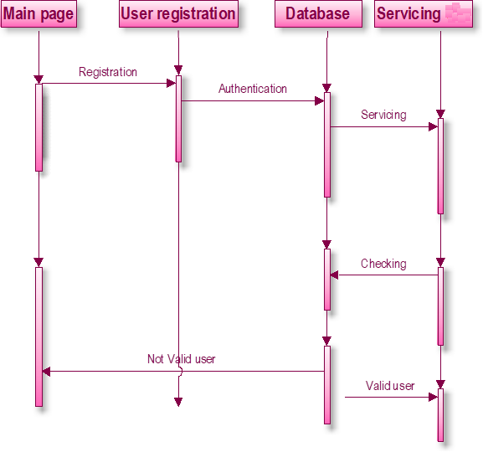

**CLASS DIAGRAM:**

Class is nothing but a structure that contains both variables and methods. The Class Diagram shows a set of classes, interfaces, and collaborations and their relating ships. There is most common diagram in modeling the object oriented systems and are used to give the static view of a system. It shows the dependency between the classes that can be used in our system.

The interactions between the modules or classes of our projects are shown below. Each block contains Class Name, Variables and Methods.

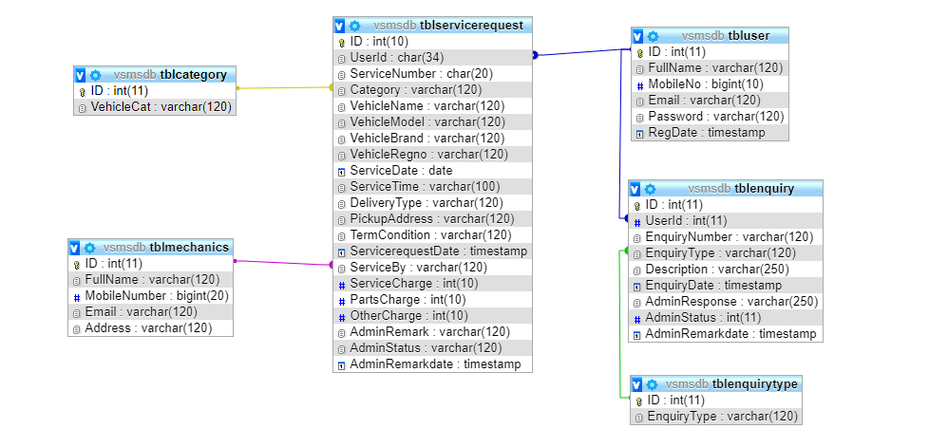

**CLASS:**

A description of set of objects that share the same attributes operations, relationships, and semantics

**DATA FLOW DIAGRAMS**:

The DFD takes an input-process-output view of a system i.e. data objects flow into the software, are transformed by processing elements, and resultant data objects flow out of the software.

Data objects represented by labeled arrows and transformation are represented by circles also called as bubbles. DFD is presented in a hierarchical fashion i.e. the first data flow model represents the system as a whole. Subsequent DFD refine the context diagram (level 0 DFD), providing increasing details with each subsequent level.

The DFD enables the software engineer to develop models of the information domain & functional domain at the same time. As the DFD is refined into greater levels of details, the analyst perform an implicit functional decomposition of the system. At the same time, the DFD refinement results in a corresponding refinement of the data as it moves through the process that embody the applications.

A context-level DFD for the system the primary external entities produce information for use by the system and consume information generated by the system. The labeled arrow represents data objects or object hierarchy.

**RULES FOR DFD:**

* Fix the scope of the system by means of context diagrams.
* Organize the DFD so that the main sequence of the actions
* Reads left to right and top to bottom.
* Identify all inputs and outputs.
* Identify and label each process internal to the system with Rounded circles.
* A process is required for all the data transformation and Transfers. Therefore, never connect a data store to a data Source or the destinations or another data store with just a Data flow arrow.
* Do not indicate hardware and ignore control information.
* Make sure the names of the processes accurately convey everything the process is done.
* There must not be unnamed process.
* Indicate external sources and destinations of the data, with Squares.
* Number each occurrence of repeated external entities.
* Identify all data flows for each process step, except simple Record retrievals.
* Label data flow on each arrow.
* Use details flow on each arrow.
* Use the details flow arrow to indicate data movements.

**DATAFLOW DIAGRAMS:**

Database:

User Registration

Servicing

Database

**user registration**

**user registration**

View Service Details

View Service Request

View Query History

Raise a query details

Request for service

Servicing Vehical

**Servicing vehical**

view Vehicals

Servicing for Car

Update service details

Servicing

**E-R Diagrams:**

The Entity-Relationship (ER) model was originally proposed by Peter in 1976 [Chen76] as a way to unify the network and relational database views. Simply stated the ER model is a conceptual data model that views the real world as entities and relationships. A basic component of the model is the Entity-Relationship diagram which is used to visually represents data objects. Since Chen wrote his paper the model has been extended and today it is commonly used for database design For the database designer, the utility of the ER model is:

* it maps well to the relational model. The constructs used in the ER model can easily be transformed into relational tables.
* it is simple and easy to understand with a minimum of training. Therefore, the model can be used by the database designer to communicate the design to the end user.
* In addition, the model can be used as a design plan by the database developer to implement a data model in a specific database management software.

## Connectivity and Cardinality

The basic types of connectivity for relations are: one-to-one, one-to-many, and many-to-many. A *one-to-one* (1:1) relationship is when at most one instance of a entity A is associated with one instance of entity B. For example, "employees in the company are each assigned their own office. For each employee there exists a unique office and for each office there exists a unique employee.

A *one-to-many* (1:N) relationships is when for one instance of entity A, there are zero, one, or many instances of entity B, but for one instance of entity B, there is only one instance of entity A. An example of a 1:N relationships is

a department has many employees each employee is assigned to one department

A *many-to-many* (M:N) relationship, sometimes called non-specific, is when for one instance of entity A, there are zero, one, or many instances of entity B and for one instance of entity B there are zero, one, or many instances of entity A. The connectivity of a relationship describes the mapping of associated

## ER Notation

There is no standard for representing data objects in ER diagrams. Each modeling methodology uses its own notation. The original notation used by Chen is widely used in academics texts and journals but rarely seen in either CASE tools or publications by non-academics. Today, there are a number of notations used, among the more common are Bachman, crow's foot, and IDEFIX.

All notational styles represent entities as rectangular boxes and relationships as lines connecting boxes. Each style uses a special set of symbols to represent the cardinality of a connection. The notation used in this document is from Martin. The symbols used for the basic ER constructs are:

* **Entities** are represented by labeled rectangles. The label is the name of the entity. Entity names should be singular nouns.
* **Relationships** are represented by a solid line connecting two entities. The name of the relationship is written above the line. Relationship names should be verbs
* **Attributes**, when included, are listed inside the entity rectangle. Attributes which are identifiers are underlined. Attribute names should be singular nouns.
* **Cardinality** of many is represented by a line ending in a crow's foot. If the crow's foot is omitted, the cardinality is one.
* **Existence** is represented by placing a circle or a perpendicular bar on the line. Mandatory existence is shown by the bar (looks like a 1) next to the entity for an instance is required. Optional existence is shown by placing a circle next to the entity that is optional

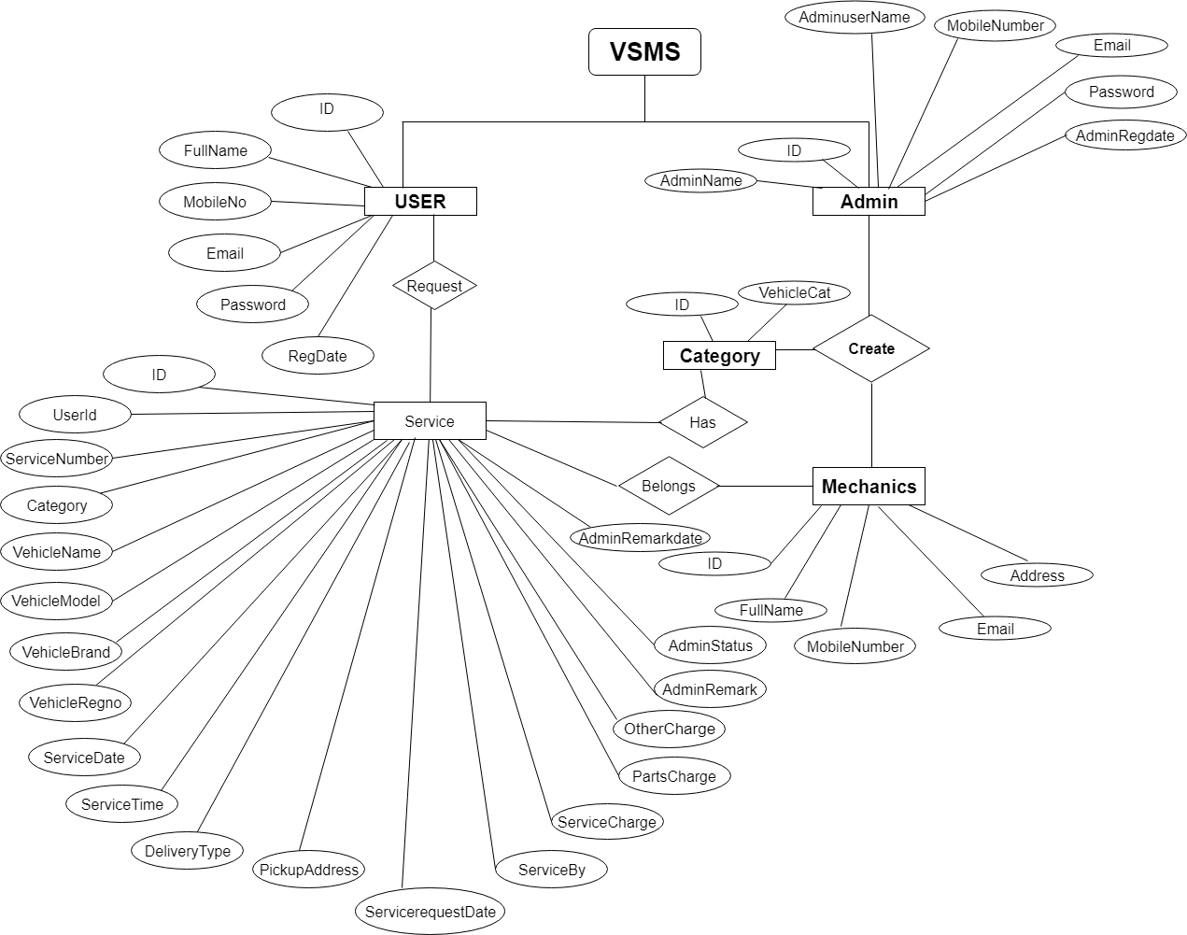

**Database Design**

The data in the system has to be stored and retrieved from database. Designing the database is part of system design. Data elements and data structures to be stored have been identified at analysis stage. They are structured and put together to design the data storage and retrieval system.

A database is a collection of interrelated data stored with minimum redundancy to serve many users quickly and efficiently. The general objective is to make database access easy, quick, inexpensive and flexible for the user. Relationships are established between the data items and unnecessary data items are removed. Normalization is done to get an internal consistency of data and to have minimum redundancy and maximum stability. This ensures minimizing data storage required, minimizing chances of data inconsistencies and optimizing for updates. The MS Access database has been chosen for developing the relevant databases.

**Car Service Management System (csmsdb) contains 7 MySQL tables :**

**tbladmin table:** (This table contain admin login details)

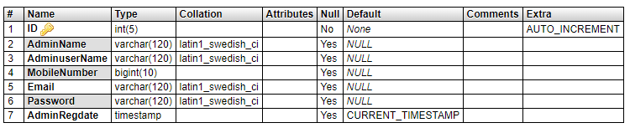

**tblcategory Table :** (This contain the Car categories)

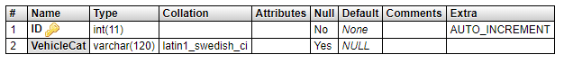

**Tblenquirytype Table :** (This table contain the type of the queries)

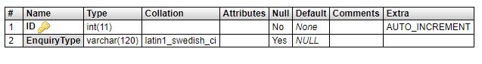

**Tblenquiry Table :** (This table contains the customers enquiries/queries.)

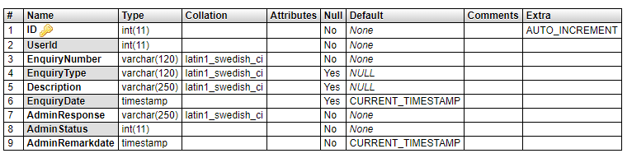

**Tblmechanics Table:** (This Table contains the mechanics details.)

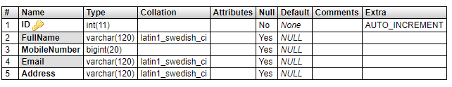

**Tbluser Table :** (This table contain the user / customer details.)

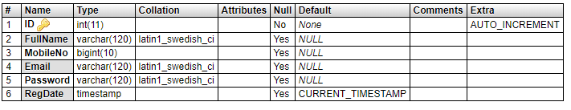

**Tblservicerequest Table :** (This table contains the Car service details.)

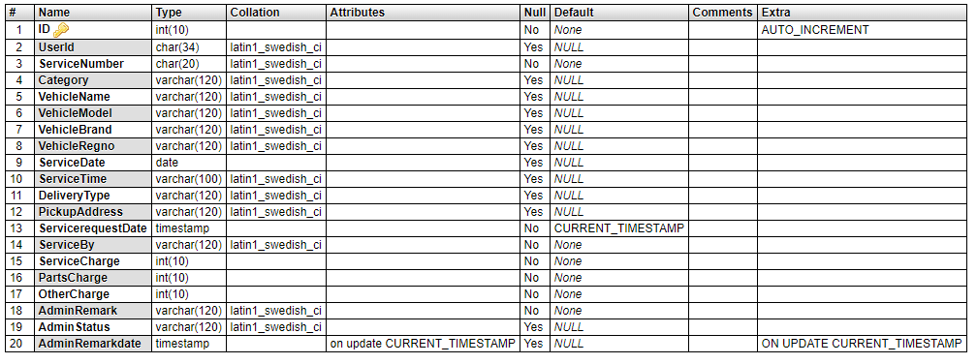

**Modules**

**Car Service Management System**

In this project we use PHP and MySQL database. It has two modules

1. User Module

2. Admin Module.

**User Module:**

1. Dashboard: In this section

2. Enquiry: In this section user can fill the enquiry form and check his query is respond or not (which is done by admin).

3. Service Request: In this section user can fill the service form, check his/her service status and what amount is taken for service and also print his/her amount slip (which is done by admin).

User can also update his/ her profile, change password and recover password.

**Admin Module**

1. Dashboard: In this section admin can see all detail in brief like total registered user, Total Enquiry, Total Mechanics and Total Services.
2. Enquiry Search: In this section admin can search enquiry with help of customer phone number, email id or contact number.
3. Service Search: In this section admin can search services with help of customer phone number, email id or contact number.
4. Mechanics: In this section admin can manage mechanics (add and update).
5. Car Category: In this section admin can manage Car category (add and update).
6. Reg Users: In this section admin can view user detail and update user detail.
7. Service Request: In this section admin can add service prices (service charge, parts charge additional (if any)). Admin can view services on the basis of status (pending services, rejected services and complete services). Admin also can approve pending policy
8. Customer Query: In this section admin can respond the customer query and also view the customer responded query and non-responded query.

Admin can also update his profile, change password and recover password.

**Note**: In this project MD5 encryption method used.

**FEASIBILITY STUDY:**

Feasibility study is conducted once the problem is clearly understood. Feasibility study is a high level capsule version of the entire system analysis and design process. The objective is to determine quickly at a minimum expense how to solve a problem. The purpose of feasibility is not to solve the problem but to determine if the problem is worth solving.

The system has been tested for feasibility in the following points.

1. Technical Feasibility

2. Economical Feasibility

3. Operational Feasibility.

1. Technical Feasibility

The project entitles "Courier Service System” is technically feasibility because of the below mentioned feature. The project was developed in Java which Graphical User Interface.

It provides the high level of reliability, availability and compatibility. All these make Java an appropriate language for this project. Thus the existing software Java is a powerful language.

2. Economic Feasibility

The computerized system will help in automate the selection leading the profits and details of the organization. With this software, the machine and manpower utilization are expected to go up by 80-90% approximately. The costs incurred of not creating the system are set to be great, because precious time can be wanted by manually.

3. Operational Feasibility

In this project, the management will know the details of each project where he may be presented and the data will be maintained as decentralized and if any inquires for that particular contract can be known as per their requirements and necessaries.

**Implementation:**

Implementation is the stage where the theoretical design is turned into a working system. The most crucial stage in achieving a new successful system and in giving confidence on the new system for the users that it will work efficiently and effectively.

The system can be implemented only after thorough testing is done and if it is found to work according to the specification.

It involves careful planning, investigation of the current system and its constraints on implementation, design of methods to achieve the change over and an evaluation of change over methods a part from planning. Two major tasks of preparing the implementation are education and training of the users and testing of the system.

The more complex the system being implemented, the more involved will be the systems analysis and design effort required just for implementation.

The implementation phase comprises of several activities. The required hardware and software acquisition is carried out. The system may require some software to be developed. For this, programs are written and tested. The user then changes over to his new fully tested system and the old system is discontinued.

**Index.php**

**<!DOCTYPE html>**

**<html lang="en">**

**<head>**

**<meta charset="utf-8">**

**<title>Car Service Management System</title>**

**<!-- Bootstrap core CSS -->**

**<link href="vendor/bootstrap/css/bootstrap.min.css" rel="stylesheet">**

**<!-- Custom fonts for this template -->**

**<link href="vendor/fontawesome-free/css/all.min.css" rel="stylesheet" type="text/css">**

**<link href="https://fonts.googleapis.com/css?family=Montserrat:400,700" rel="stylesheet" type="text/css">**

**<link href="https://fonts.googleapis.com/css?family=Lato:400,700,400italic,700italic" rel="stylesheet" type="text/css">**

**<!-- Plugin CSS -->**

**<link href="vendor/magnific-popup/magnific-popup.css" rel="stylesheet" type="text/css">**

**<!-- Custom styles for this template -->**

**<link href="css/freelancer.min.css" rel="stylesheet">**

**</head>**

**<body id="page-top">**

**<!-- Navigation -->**

**<nav class="navbar navbar-expand-lg bg-secondary fixed-top text-uppercase" id="mainNav">**

**<div class="container">**

**<a class="navbar-brand js-scroll-trigger" href="#page-top">Car Service Management System (CSMS)</a>**

**<button class="navbar-toggler navbar-toggler-right text-uppercase bg-primary text-white rounded" type="button" data-toggle="collapse" data-target="#navbarResponsive" aria-controls="navbarResponsive" aria-expanded="false" aria-label="Toggle navigation">**

**Menu**

**<i class="fas fa-bars"></i>**

**</button>**

**<div class="collapse navbar-collapse" id="navbarResponsive">**

**<ul class="navbar-nav ml-auto">**

**<li class="nav-item mx-0 mx-lg-1">**

**<a class="nav-link py-3 px-0 px-lg-3 rounded js-scroll-trigger" href="user/">User</a>**

**</li>**

**<li class="nav-item mx-0 mx-lg-1">**

**<a class="nav-link py-3 px-0 px-lg-3 rounded js-scroll-trigger" href="admin/">Admin</a>**

**</li>**

**</ul>**

**</div>**

**</div>**

**</nav>**

**<!-- Header -->**

**<header class="masthead bg-primary text-white text-center">**

**<div class="container">**

**<img class="img-fluid mb-5 d-block mx-auto" src="img/profile.png" height="200" width="200">**

**<h1 class="text-uppercase mb-0">CSMS</h1>**

**<hr class="star-light">**

**<h2 class="font-weight-light mb-0">Developed using PHP & MySQL</h2>**

**</div>**

**</header>**

**<div class="copyright py-4 text-center text-white">**

**<div class="container">**

**<small>Copyright &copy; Car Service Management System (CSMS) 2019</small>**

**</div>**

**</div>**

**<!-- Scroll to Top Button (Only visible on small and extra-small screen sizes) -->**

**<div class="scroll-to-top d-lg-none position-fixed ">**

**<a class="js-scroll-trigger d-block text-center text-white rounded" href="#page-top">**

**<i class="fa fa-chevron-up"></i>**

**</a>**

**</div>**

**<!-- Portfolio Modals -->**

**<!-- Portfolio Modal 1 -->**

**<div class="portfolio-modal mfp-hide" id="portfolio-modal-1">**

**<div class="portfolio-modal-dialog bg-white">**

**<a class="close-button d-none d-md-block portfolio-modal-dismiss" href="#">**

**<i class="fa fa-3x fa-times"></i>**

**</a>**

**<div class="container text-center">**

**<div class="row">**

**<div class="col-lg-8 mx-auto">**

**<h2 class="text-secondary text-uppercase mb-0">Project Name</h2>**

**<hr class="star-dark mb-5">**

**<img class="img-fluid mb-5" src="img/portfolio/cabin.png" alt="">**

**<p class="mb-5">Lorem ipsum dolor sit amet, consectetur adipisicing elit. Mollitia neque assumenda ipsam nihil, molestias magnam, recusandae quos quis inventore quisquam velit asperiores, vitae? Reprehenderit soluta, eos quod consequuntur itaque. Nam.</p>**

**<a class="btn btn-primary btn-lg rounded-pill portfolio-modal-dismiss" href="#">**

**<i class="fa fa-close"></i>**

**Close Project</a>**

**</div>**

**</div>**

**</div>**

**</div>**

**</div>**

**<!-- Portfolio Modal 2 -->**

**<div class="portfolio-modal mfp-hide" id="portfolio-modal-2">**

**<div class="portfolio-modal-dialog bg-white">**

**<a class="close-button d-none d-md-block portfolio-modal-dismiss" href="#">**

**<i class="fa fa-3x fa-times"></i>**

**</a>**

**<div class="container text-center">**

**<div class="row">**

**<div class="col-lg-8 mx-auto">**

**<h2 class="text-secondary text-uppercase mb-0">Project Name</h2>**

**<hr class="star-dark mb-5">**

**<img class="img-fluid mb-5" src="img/portfolio/cake.png" alt="">**

**<p class="mb-5">Lorem ipsum dolor sit amet, consectetur adipisicing elit. Mollitia neque assumenda ipsam nihil, molestias magnam, recusandae quos quis inventore quisquam velit asperiores, vitae? Reprehenderit soluta, eos quod consequuntur itaque. Nam.</p>**

**<a class="btn btn-primary btn-lg rounded-pill portfolio-modal-dismiss" href="#">**

**<i class="fa fa-close"></i>**

**Close Project</a>**

**</div>**

**</div>**

**</div>**

**</div>**

**</div>**

**<!-- Portfolio Modal 3 -->**

**<div class="portfolio-modal mfp-hide" id="portfolio-modal-3">**

**<div class="portfolio-modal-dialog bg-white">**

**<a class="close-button d-none d-md-block portfolio-modal-dismiss" href="#">**

**<i class="fa fa-3x fa-times"></i>**

**</a>**

**<div class="container text-center">**

**<div class="row">**

**<div class="col-lg-8 mx-auto">**

**<h2 class="text-secondary text-uppercase mb-0">Project Name</h2>**

**<hr class="star-dark mb-5">**

**<img class="img-fluid mb-5" src="img/portfolio/circus.png" alt="">**

**<p class="mb-5">Lorem ipsum dolor sit amet, consectetur adipisicing elit. Mollitia neque assumenda ipsam nihil, molestias magnam, recusandae quos quis inventore quisquam velit asperiores, vitae? Reprehenderit soluta, eos quod consequuntur itaque. Nam.</p>**

**<a class="btn btn-primary btn-lg rounded-pill portfolio-modal-dismiss" href="#">**

**<i class="fa fa-close"></i>**

**Close Project</a>**

**</div>**

**</div>**

**</div>**

**</div>**

**</div>**

**<!-- Portfolio Modal 4 -->**

**<div class="portfolio-modal mfp-hide" id="portfolio-modal-4">**

**<div class="portfolio-modal-dialog bg-white">**

**<a class="close-button d-none d-md-block portfolio-modal-dismiss" href="#">**

**<i class="fa fa-3x fa-times"></i>**

**</a>**

**<div class="container text-center">**

**<div class="row">**

**<div class="col-lg-8 mx-auto">**

**<h2 class="text-secondary text-uppercase mb-0">Project Name</h2>**

**<hr class="star-dark mb-5">**

**<img class="img-fluid mb-5" src="img/portfolio/game.png" alt="">**

**<p class="mb-5">Lorem ipsum dolor sit amet, consectetur adipisicing elit. Mollitia neque assumenda ipsam nihil, molestias magnam, recusandae quos quis inventore quisquam velit asperiores, vitae? Reprehenderit soluta, eos quod consequuntur itaque. Nam.</p>**

**<a class="btn btn-primary btn-lg rounded-pill portfolio-modal-dismiss" href="#">**

**<i class="fa fa-close"></i>**

**Close Project</a>**

**</div>**

**</div>**

**</div>**

**</div>**

**</div>**

**<!-- Portfolio Modal 5 -->**

**<div class="portfolio-modal mfp-hide" id="portfolio-modal-5">**

**<div class="portfolio-modal-dialog bg-white">**

**<a class="close-button d-none d-md-block portfolio-modal-dismiss" href="#">**

**<i class="fa fa-3x fa-times"></i>**

**</a>**

**<div class="container text-center">**

**<div class="row">**

**<div class="col-lg-8 mx-auto">**

**<h2 class="text-secondary text-uppercase mb-0">Project Name</h2>**

**<hr class="star-dark mb-5">**

**<img class="img-fluid mb-5" src="img/portfolio/safe.png" alt="">**

**<p class="mb-5">Lorem ipsum dolor sit amet, consectetur adipisicing elit. Mollitia neque assumenda ipsam nihil, molestias magnam, recusandae quos quis inventore quisquam velit asperiores, vitae? Reprehenderit soluta, eos quod consequuntur itaque. Nam.</p>**

**<a class="btn btn-primary btn-lg rounded-pill portfolio-modal-dismiss" href="#">**

**<i class="fa fa-close"></i>**

**Close Project</a>**

**</div>**

**</div>**

**</div>**

**</div>**

**</div>**

**<!-- Portfolio Modal 6 -->**

**<div class="portfolio-modal mfp-hide" id="portfolio-modal-6">**

**<div class="portfolio-modal-dialog bg-white">**

**<a class="close-button d-none d-md-block portfolio-modal-dismiss" href="#">**

**<i class="fa fa-3x fa-times"></i>**

**</a>**

**<div class="container text-center">**

**<div class="row">**

**<div class="col-lg-8 mx-auto">**

**<h2 class="text-secondary text-uppercase mb-0">Project Name</h2>**

**<hr class="star-dark mb-5">**

**<img class="img-fluid mb-5" src="img/portfolio/submarine.png" alt="">**

**<p class="mb-5">Lorem ipsum dolor sit amet, consectetur adipisicing elit. Mollitia neque assumenda ipsam nihil, molestias magnam, recusandae quos quis inventore quisquam velit asperiores, vitae? Reprehenderit soluta, eos quod consequuntur itaque. Nam.</p>**

**<a class="btn btn-primary btn-lg rounded-pill portfolio-modal-dismiss" href="#">**

**<i class="fa fa-close"></i>**

**Close Project</a>**

**</div>**

**</div>**

**</div>**

**</div>**

**</div>**

**<!-- Bootstrap core JavaScript -->**

**<script src="vendor/jquery/jquery.min.js"></script>**

**<script src="vendor/bootstrap/js/bootstrap.bundle.min.js"></script>**

**<!-- Plugin JavaScript -->**

**<script src="vendor/jquery-easing/jquery.easing.min.js"></script>**

**<script src="vendor/magnific-popup/jquery.magnific-popup.min.js"></script>**

**<!-- Contact Form JavaScript -->**

**<script src="js/jqBootstrapValidation.js"></script>**

**<script src="js/contact_me.js"></script>**

**<!-- Custom scripts for this template -->**

**<script src="js/freelancer.min.js"></script>**

**</body>**

**</html>**

**Welcome.php**

**<?php**

**session_start();**

**error_reporting(0);**

**include('includes/dbconnection.php');**

**if (strlen($_SESSION['adid']==0)) {**

**header('location:logout.php');**

**}**

**?>**

**<!doctype html>**

**<html lang="en">**

**<head>**

**<meta charset="utf-8" />**

**<title>Car Service Managment System</title>**

**<meta name="viewport" content="width=device-width, initial-scale=1, shrink-to-fit=no">**

**<meta content="A fully featured admin theme which can be used to build CRM, CMS, etc." name="description" />**

**<meta content="Coderthemes" name="author" />**

**<meta http-equiv="X-UA-Compatible" content="IE=edge" />**

**<!-- App favicon -->**

**<link rel="shortcut icon" href="assets/images/favicon.ico">**

**<!-- App css -->**

**<link href="assets/css/bootstrap.min.css" rel="stylesheet" type="text/css" />**

**<link href="assets/css/icons.css" rel="stylesheet" type="text/css" />**

**<link href="assets/css/metismenu.min.css" rel="stylesheet" type="text/css" />**

**<link href="assets/css/style.css" rel="stylesheet" type="text/css" />**

**<script src="assets/js/modernizr.min.js"></script>**

**</head>**

**<body>**

**<!-- Begin page -->**

**<div id="wrapper">**

**<?php include_once('includes/sidebar.php');?>**

**<!-- ============================================================== -->**

**<!-- Start right Content here -->**

**<!-- ============================================================== -->**

**<div class="content-page">**

**<?php include_once('includes/header.php');?>**

**<!-- Start Page content -->**

**<div class="content">**

**<div class="container-fluid">**

**<div class="row">**

**<div class="col-12">**

**<div class="card-box">**

**<h4 class="header-title mb-4">Account Overview</h4>**

**<div class="row">**

**<div class="col-sm-6 col-lg-6 col-xl-3">**

**<div class="card-box mb-0 widget-chart-two">**

**<div class="float-right">**

**<input data-plugin="knob" data-width="80" data-height="80" data-linecap=round**

**data-fgColor="#0acf97" value="" data-skin="tron" data-angleOffset="180"**

**data-readOnly=true data-thickness=".1"/>**

**</div>**

**<div class="widget-chart-two-content">**

**<?php $query=mysqli_query($con,"Select * from tbluser");**

**$usercount=mysqli_num_rows($query);**

**?>**

**<p class="text-muted mb-0 mt-2">Total Registered User</p>**

**<h3 class=""><?php echo $usercount;?></h3>**

**</div>**

**</div>**

**</div>**

**<div class="col-sm-6 col-lg-6 col-xl-3">**

**<div class="card-box mb-0 widget-chart-two">**

**<div class="float-right">**

**<input data-plugin="knob" data-width="80" data-height="80" data-linecap=round**

**data-fgColor="#f9bc0b" value="" data-skin="tron" data-angleOffset="180"**

**data-readOnly=true data-thickness=".1"/>**

**</div>**

**<div class="widget-chart-two-content">**

**<?php $query1=mysqli_query($con,"Select * from tblenquiry");**

**$enqcount=mysqli_num_rows($query1);**

**?>**

**<p class="text-muted mb-0 mt-2">Total Enquiry</p>**

**<h3 class=""><?php echo $enqcount;?></h3>**

**</div>**

**</div>**

**</div>**

**<div class="col-sm-6 col-lg-6 col-xl-3">**

**<div class="card-box mb-0 widget-chart-two">**

**<div class="float-right">**

**<input data-plugin="knob" data-width="80" data-height="80" data-linecap=round**

**data-fgColor="#f1556c" value="14" data-skin="tron" data-angleOffset="180"**

**data-readOnly=true data-thickness=".1"/>**

**</div>**

**<div class="widget-chart-two-content">**

**<?php $query2=mysqli_query($con,"Select * from tblmechanics");**

**$meccount=mysqli_num_rows($query2);**

**?>**

**<p class="text-muted mb-0 mt-2">Total Enquiry</p>**

**<h3 class=""><?php echo $meccount;?></h3>**

**</div>**

**</div>**

**</div>**

**<div class="col-sm-6 col-lg-6 col-xl-3">**

**<div class="card-box mb-0 widget-chart-two">**

**<div class="float-right">**

**<input data-plugin="knob" data-width="80" data-height="80" data-linecap=round**

**data-fgColor="#2d7bf4" value="60" data-skin="tron" data-angleOffset="180"**

**data-readOnly=true data-thickness=".1"/>**

**</div>**

**<div class="widget-chart-two-content">**

**<p class="text-muted mb-0 mt-2">Total Revenue</p>**

**<h3 class="">$32,540</h3>**

**</div>**

**</div>**

**</div>**

**</div>**

**<!-- end row -->**

**</div>**

**</div>**

**</div>**

**<!-- end row -->**

**<!-- end row -->**

**</div> <!-- container -->**

**</div> <!-- content -->**

**<?php include_once('includes/footer.php');?>**

**</div>**

**<!-- ============================================================== -->**

**<!-- End Right content here -->**

**<!-- ============================================================== -->**

**</div>**

**<!-- END wrapper -->**

**<!-- jQuery -->**

**<script src="assets/js/jquery.min.js"></script>**

**<script src="assets/js/bootstrap.bundle.min.js"></script>**

**<script src="assets/js/metisMenu.min.js"></script>**

**<script src="assets/js/waves.js"></script>**

**<script src="assets/js/jquery.slimscroll.js"></script>**

**<!-- App js -->**

**<script src="assets/js/jquery.core.js"></script>**

**<script src="assets/js/jquery.app.js"></script>**

**</body>**

**</html>**

**Admin-profile.php**

**<?php**

**session_start();**

**error_reporting(0);**

**include('includes/dbconnection.php');**

**error_reporting(0);**

**if (strlen($_SESSION['adid']==0)) {**

**header('location:logout.php');**

**} else{**

**if(isset($_POST['submit']))**

**{**

**$adminid=$_SESSION['adid'];**

**$AName=$_POST['adminname'];**

**$query=mysqli_query($con, "update tbladmin set AdminName='$AName' where ID='$adminid'");**

**if ($query) {**

**$msg="Admin profile has been updated.";**

**}**

**else**

**{**

**$msg="Something Went Wrong. Please try again.";**

**}**

**}**

**?>**

**<!doctype html>**

**<html lang="en">**

**<head>**

**<meta charset="utf-8" />**

**<title>Car Service Managment System</title>**

**<meta name="viewport" content="width=device-width, initial-scale=1, shrink-to-fit=no">**

**<meta content="A fully featured admin theme which can be used to build CRM, CMS, etc." name="description" />**

**<meta content="Coderthemes" name="author" />**

**<meta http-equiv="X-UA-Compatible" content="IE=edge" />**

**<!-- App favicon -->**

**<link rel="shortcut icon" href="assets/images/favicon.ico">**

**<!-- App css -->**

**<link href="assets/css/bootstrap.min.css" rel="stylesheet" type="text/css" />**

**<link href="assets/css/icons.css" rel="stylesheet" type="text/css" />**

**<link href="assets/css/metismenu.min.css" rel="stylesheet" type="text/css" />**

**<link href="assets/css/style.css" rel="stylesheet" type="text/css" />**

**<script src="assets/js/modernizr.min.js"></script>**

**</head>**

**<body>**

**<!-- Begin page -->**

**<div id="wrapper">**

**<?php include_once('includes/sidebar.php');?>**

**<!-- ============================================================== -->**

**<!-- Start right Content here -->**

**<!-- ============================================================== -->**

**<div class="content-page">**

**<?php include_once('includes/header.php');?>**

**<!-- Start Page content -->**

**<div class="content">**

**<div class="container-fluid">**

**<div class="row">**

**<div class="col-12">**

**<div class="card-box">**

**<h4 class="m-t-0 header-title">Update Admin Profile</h4>**

**<p class="text-muted m-b-30 font-14">**

**</p>**

**<div class="row">**

**<div class="col-12">**

**<div class="p-20">**

**<p style="font-size:16px; color:red" align="center"> <?php if($msg){**

**echo $msg;**

**} ?> </p>**

**<form class="form-horizontal" role="form" method="post" >**

**<?php**

**$adminid=$_SESSION['adid'];**

**$ret=mysqli_query($con,"select * from tbladmin where ID='$adminid'");**

**$cnt=1;**

**while ($row=mysqli_fetch_array($ret)) {**

**?>**

**<div class="form-group row">**

**<label class="col-2 col-form-label" for="example-email">Admin Name</label>**

**<div class="col-10">**

**<input type="text" id="adminname" name="adminname" class="form-control" required="true" value="<?php echo $row['AdminName'];?>">**

**</div>**

**</div>**

**<div class="form-group row">**

**<label class="col-2 col-form-label">Mobile Number</label>**

**<div class="col-10">**

**<input type="text" class="form-control" name="mobilenumber" id="mobilenumber" required="true" readonly="true" value="<?php echo $row['MobileNumber'];?>">**

**</div>**

**</div>**

**<div class="form-group row">**

**<label class="col-2 col-form-label">Email</label>**

**<div class="col-10">**

**<input type="email" class="form-control" name="email" id="email" required="true" readonly="true" value="<?php echo $row['Email'];?>">**

**</div>**

**</div>**

**<div class="form-group row">**

**<label class="col-2 col-form-label">Admin Registration Date</label>**

**<div class="col-10">**

**<input type="text" class="form-control" name="regdate" id="regdate" required="true" readonly="true" value="<?php echo $row['AdminRegdate'];?>">**

**</div>**

**</div>**

**<?php } ?>**

**<div class="form-group row">**

**<div class="col-12">**

**<button type="submit" name="submit" class="btn btn-info btn-min-width mr-1 mb-1">Update</button>**

**</div>**

**</div>**

**</form>**

**</div>**

**</div>**

**</div>**

**<!-- end row -->**

**</div> <!-- end card-box -->**

**</div><!-- end col -->**

**</div>**

**<!-- end row -->**

**<!-- end row -->**

**</div> <!-- container -->**

**</div> <!-- content -->**

**<?php include_once('includes/footer.php');?>**

**</div>**

**<!-- ============================================================== -->**

**<!-- End Right content here -->**

**<!-- ============================================================== -->**

**</div>**

**<!-- END wrapper -->**

**<!-- jQuery -->**

**<script src="assets/js/jquery.min.js"></script>**

**<script src="assets/js/bootstrap.bundle.min.js"></script>**

**<script src="assets/js/metisMenu.min.js"></script>**

**<script src="assets/js/waves.js"></script>**

**<script src="assets/js/jquery.slimscroll.js"></script>**

**<!-- App js -->**

**<script src="assets/js/jquery.core.js"></script>**

**<script src="assets/js/jquery.app.js"></script>**

**</body>**

**</html>**

**<?php } ?>**

**Service-request.php**

**<?php**

**session_start();**

**error_reporting(0);**

**include('includes/dbconnection.php');**

**if (strlen($_SESSION['sid']==0)) {**

**header('location:logout.php');**

**} else{**

**if(isset($_POST['submit']))**

**{**

**$uid=$_SESSION['sid'];**

**$category=$_POST['category'];**

**$vehname=$_POST['Carname'];**

**$vehmodel=$_POST['vehilemodel'];**

**$vehbrand=$_POST['Carbrand'];**

**$vehrego=$_POST['Carregno'];**

**$vehservicedate=$_POST['servicedate'];**

**$vehservicetime=$_POST['servicetime'];**

**$deltype=$_POST['deltype'];**

**$pickupadd=$_POST['pickupadd'];**

**$sernumber = mt_rand(100000000, 999999999);**

**$query=mysqli_query($con,"insert into tblservicerequest(UserId,Category,ServiceNumber,CarName,CarModel,CarBrand,CarRegno,ServiceDate,ServiceTime,DeliveryType,PickupAddress) value('$uid','$category','$sernumber','$vehname','$vehmodel','$vehbrand','$vehrego','$vehservicedate','$vehservicetime','$deltype','$pickupadd')");**

**if ($query) {**

**$msg="Data has been added successfully.";**

**}**

**else**

**{**

**$msg="Something Went Wrong. Please try again";**

**}**

**}**

**}**

**?>**

**<!doctype html>**

**<html lang="en">**

**<head>**

**<meta charset="utf-8" />**

**<title>Car Service Managment System</title>**

**<meta name="viewport" content="width=device-width, initial-scale=1, shrink-to-fit=no">**

**<meta content="A fully featured admin theme which can be used to build CRM, CMS, etc." name="description" />**

**<meta content="Coderthemes" name="author" />**

**<meta http-equiv="X-UA-Compatible" content="IE=edge" />**

**<!-- App favicon -->**

**<link rel="shortcut icon" href="assets/images/favicon.ico">**

**<!-- App css -->**

**<link href="assets/css/bootstrap.min.css" rel="stylesheet" type="text/css" />**

**<link href="assets/css/icons.css" rel="stylesheet" type="text/css" />**

**<link href="assets/css/metismenu.min.css" rel="stylesheet" type="text/css" />**

**<link href="assets/css/style.css" rel="stylesheet" type="text/css" />**

**<script type="text/javascript" src="http://ajax.googleapis.com/ajax/libs/jquery/1.11.1/jquery.min.js"></script>**

**<script src="assets/js/modernizr.min.js"></script>**

**<script type="text/javascript">**

**$(document).ready(function () {**

**$('#pickupaddress').hide();**

**$('#deltype').change(function () {**

**var v = $("#deltype").val();**

**if(v=='dropservice')**

**{**

**$('#pickupaddress').hide();**

**}**

**if(v=='pickupservice')**

**{**

**$('#pickupaddress').show();**

**}**

**});**

**});**

**</script>**

**</head>**

**<body>**

**<!-- Begin page -->**

**<div id="wrapper">**

**<?php include_once('includes/sidebar.php');?>**

**<!-- ============================================================== -->**

**<!-- Start right Content here -->**

**<!-- ============================================================== -->**

**<div class="content-page">**

**<?php include_once('includes/header.php');?>**

**<!-- Start Page content -->**

**<div class="content">**

**<div class="container-fluid">**

**<div class="row">**

**<div class="col-12">**

**<div class="card-box">**

**<h4 class="m-t-0 header-title">Service Request Form</h4>**

**<p class="text-muted m-b-30 font-14">**

**</p>**

**<div class="row">**

**<div class="col-12">**

**<div class="p-20">**

**<p style="font-size:16px; color:red" align="center"> <?php if($msg){**

**echo $msg;**

**} ?> </p>**

**<form class="form-horizontal" role="form" method="post" name="submit">**

**<div class="form-group row">**

**<label class="col-2 col-form-label">Category</label>**

**<div class="col-10">**

**<select name='category' id="category" class="form-control" required="true">**

**<option value="">Category</option>**

**<?php $query=mysqli_query($con,"select * from tblcategory");**

**while($row=mysqli_fetch_array($query))**

**{**

**?>**

**<option value="<?php echo $row['CarCat'];?>"><?php echo $row['CarCat'];?></option>**

**<?php } ?>**

**</select>**

**</div>**

**</div>**

**<div class="form-group row">**

**<label class="col-2 col-form-label" for="example-email">Car Name</label>**

**<div class="col-10">**

**<input type="text" id="Carname" name="Carname" class="form-control" placeholder="Car Name" required="true">**

**</div>**

**</div>**

**<div class="form-group row">**

**<label class="col-2 col-form-label">Car Model</label>**

**<div class="col-10">**

**<input type="text" class="form-control" name="vehilemodel" id="vehilemodel" required="true">**

**</div>**

**</div>**

**<div class="form-group row">**

**<label class="col-2 col-form-label">Car Brand</label>**

**<div class="col-10">**

**<input type="text" class="form-control" placeholder="Brand" name="Carbrand" id="Carbrand" required="true">**

**</div>**

**</div>**

**<div class="form-group row">**

**<label class="col-2 col-form-label">Car Registration Number</label>**

**<div class="col-10">**

**<input type="text" class="form-control" name="Carregno" id="Carregno" required="true">**

**</div>**

**</div>**

**<div class="form-group row">**

**<label class="col-2 col-form-label">Service Date</label>**

**<div class="col-10">**

**<input type="date" class="form-control" name="servicedate" id="servicedate" required="true">**

**</div>**

**</div>**

**<div class="form-group row">**

**<label class="col-2 col-form-label">Service Time</label>**

**<div class="col-10">**

**<input type="time" class="form-control" name="servicetime" id="servicetime" required="true">**

**</div>**

**</div>**

**<div class="form-group row">**

**<label class="col-2 col-form-label">Delivery Type</label>**

**<div class="col-10">**

**<select name="deltype" id="deltype" required="true" class="form-control">**

**<option value="">Select</option>**

**<option value="pickupservice">Pickup Service</option>**

**<option value="dropservice">Drop Service</option>**

**</select>**

**</div>**

**</div>**

**<div class="form-group row" id="pickupaddress">**

**<label class="col-2 col-form-label">Pickup Address</label>**

**<div class="col-10">**

**<input type="text" class="form-control" name="pickupadd" id="pickupadd">**

**</div>**

**</div>**

**<div class="col-12">**

**<div class="checkbox checkbox-custom">**

**<input id="remember" type="checkbox" checked="true">**

**<label for="remember">**

**I accept <a href="terms-conditions.php" class="text-custom">Terms and Conditions</a>**

**</label>**

**</div>**

**</div>**

**<div class="form-group row">**

**<div class="col-12">**

**<p style="text-align: center;"> <button type="submit" name="submit" class="btn btn-info btn-min-width mr-1 mb-1">Submit</button></p>**

**</div>**

**</div>**

**</form>**

**</div>**

**</div>**

**</div>**

**<!-- end row -->**

**</div> <!-- end card-box -->**

**</div><!-- end col -->**

**</div>**

**<!-- end row -->**

**<!-- end row -->**

**</div> <!-- container -->**

**</div> <!-- content -->**

**<?php include_once('includes/footer.php');?>**

**</div>**

**<!-- ============================================================== -->**

**<!-- End Right content here -->**

**<!-- ============================================================== -->**

**</div>**

**<!-- END wrapper -->**

**<!-- jQuery -->**

**<script src="assets/js/jquery.min.js"></script>**

**<script src="assets/js/bootstrap.bundle.min.js"></script>**

**<script src="assets/js/metisMenu.min.js"></script>**

**<script src="assets/js/waves.js"></script>**

**<script src="assets/js/jquery.slimscroll.js"></script>**

**<!-- App js -->**

**<script src="assets/js/jquery.core.js"></script>**

**<script src="assets/js/jquery.app.js"></script>**

**</body>**

**</html>**

**TESTING:**

Testing is a process of executing a program with the intent of finding an error. Testing is a crucial element of software quality assurance and presents ultimate review of specification, design and coding.

System Testing is an important phase. Testing represents an interesting anomaly for the software. Thus a series of testing are performed for the proposed system before the system is ready for user acceptance testing.

A good test case is one that has a high probability of finding an as undiscovered error. A successful test is one that uncovers an as undiscovered error.

Testing Objectives:

1. Testing is a process of executing a program with the intent of finding an error
2. A good test case is one that has a probability of finding an as yet undiscovered error
3. A successful test is one that uncovers an undiscovered error

Testing Principles:

* All tests should be traceable to end user requirements
* Tests should be planned long before testing begins
* Testing should begin on a small scale and progress towards testing in large
* Exhaustive testing is not possible
* To be most effective testing should be conducted by a independent third party

The primary objective for test case design is to derive a set of tests that has the highest livelihood for uncovering defects in software. To accomplish this objective two different categories of test case design techniques are used. They are

* White box testing.
* Black box testing.

# White-box testing:

White box testing focus on the program control structure. Test cases are derived to ensure that all statements in the program have been executed at least once during testing and that all logical conditions have been executed.

# Block-box testing:

Black box testing is designed to validate functional requirements without regard to the internal workings of a program. Black box testing mainly focuses on the information domain of the software, deriving test cases by partitioning input and output in a manner that provides through test coverage. Incorrect and missing functions, interface errors, errors in data structures, error in functional logic are the errors falling in this category.

Testing strategies:

A strategy for software testing must accommodate low-level tests that are necessary to verify that all small source code segment has been correctly implemented as well as high-level tests that validate major system functions against customer requirements.

Testing fundamentals:

Testing is a process of executing program with the intent of finding error. A good test case is one that has high probability of finding an undiscovered error. If testing is conducted successfully it uncovers the errors in the software. Testing cannot show the absence of defects, it can only show that software defects present.

Testing Information flow:

Information flow for testing flows the pattern. Two class of input provided to test the process. The software configuration includes a software requirements specification, a design specification and source code.

Test configuration includes test plan and test cases and test tools. Tests are conducted and all the results are evaluated. That is test results are compared with expected results. When erroneous data are uncovered, an error is implied and debugging commences.

Unit testing:

Unit testing is essential for the verification of the code produced during the coding phase and hence the goal is to test the internal logic of the modules. Using the detailed design description as a guide, important paths are tested to uncover errors with in the boundary of the modules. These tests were carried out during the programming stage itself. All units of ViennaSQL were successfully tested.

Integration testing :

Integration testing focuses on unit tested modules and build the program structure that is dictated by the design phase.

System testing:

System testing tests the integration of each module in the system. It also tests to find discrepancies between the system and it’s original objective, current specification and system documentation. The primary concern is the compatibility of individual modules. Entire system is working properly or not will be tested here, and specified path ODBC connection will correct or not, and giving output or not are tested here these verifications and validations are done by giving input values to the system and by comparing with expected output. Top-down testing implementing here.

## Acceptance Testing:

This testing is done to verify the readiness of the system for the implementation. Acceptance testing begins when the system is complete. Its purpose is to provide the end user with the confidence that the system is ready for use. It involves planning and execution of functional tests, performance tests and stress tests in order to demonstrate that the implemented system satisfies its requirements.

Tools to special importance during acceptance testing include:

Test coverage Analyzer – records the control paths followed for each test case.

Timing Analyzer – also called a profiler, reports the time spent in various regions of the code are areas to concentrate on to improve system performance.

Coding standards – static analyzers and standard checkers are used to inspect code for deviations from standards and guidelines.

Test Cases:

Test cases are derived to ensure that all statements in the program have been executed at least once during testing and that all logical conditions have been executed.

Using White-Box testing methods, the software engineer can drive test cases that

* Guarantee that logical decisions on their true and false sides.
* Exercise all logical decisions on their true and false sides.
* Execute all loops at their boundaries and within their operational bounds.
* Exercise internal data structure to assure their validity.

The test case specification for system testing has to be submitted for review before system testing commences.

Output Screens

**User / Customer Signup Page**

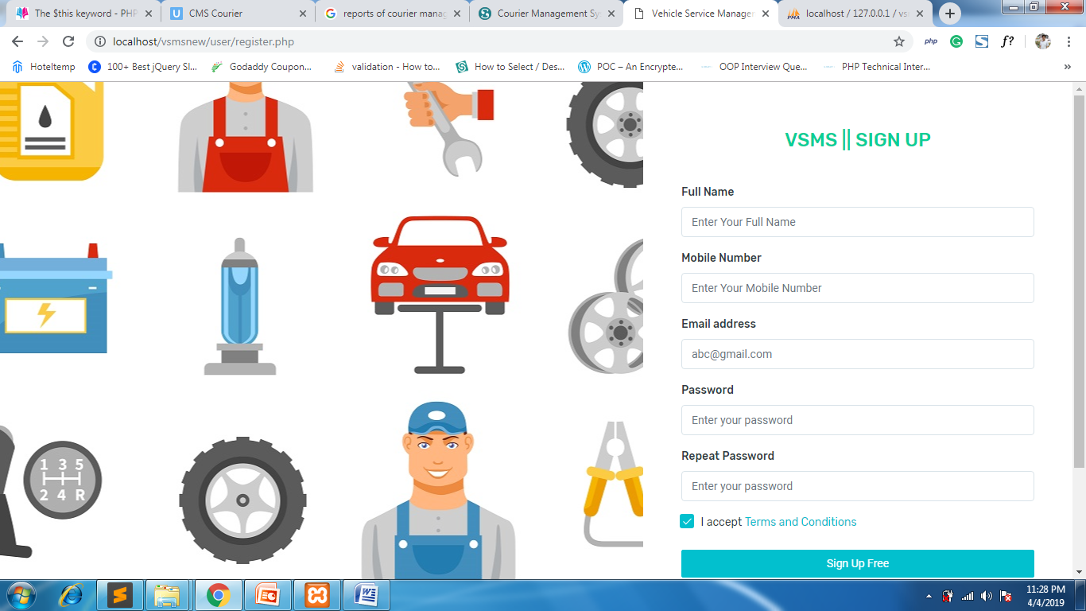

**User / Customer login Page**

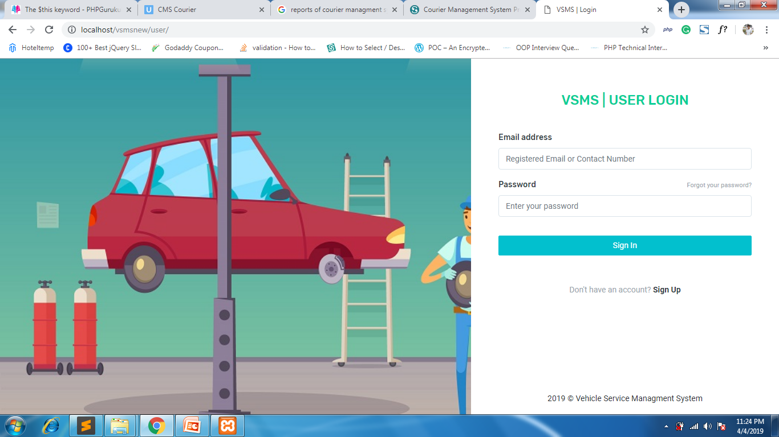

**User / Customer Password Recovery**

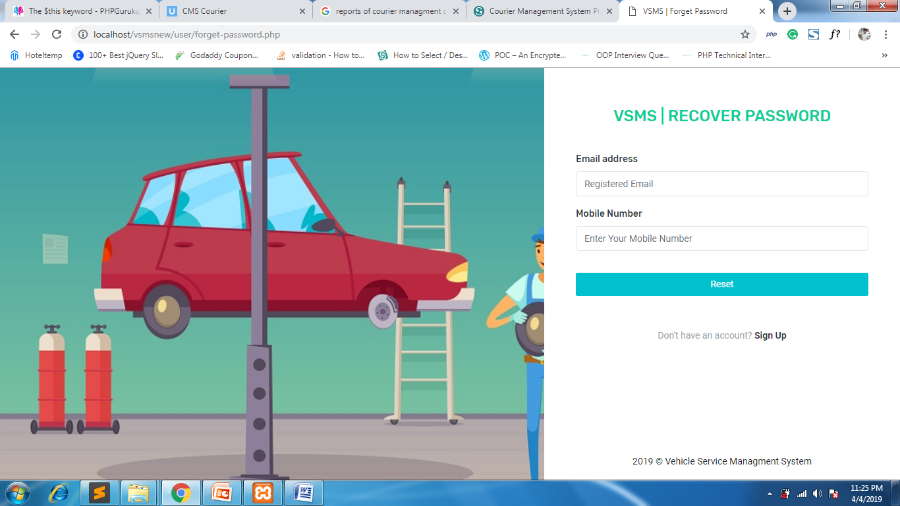

**Reset Password Page**

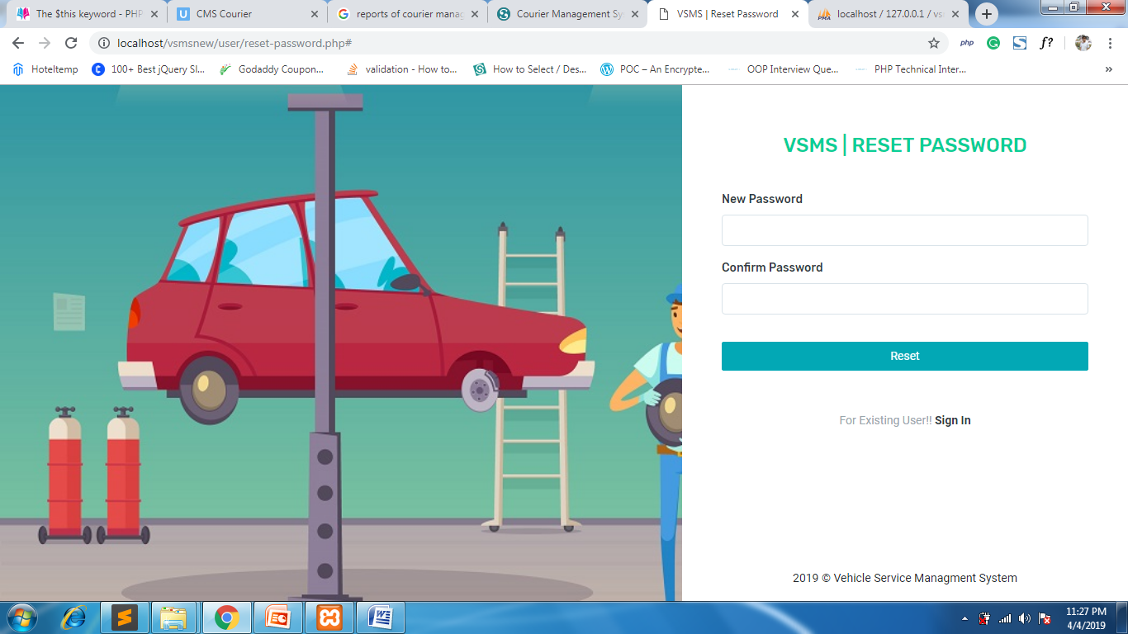

**User / Customer Welcome Page after Successful login**

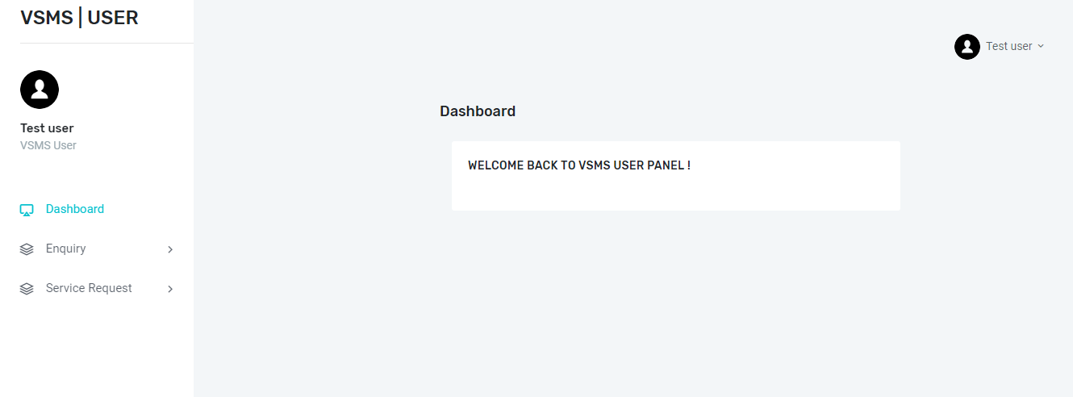

**User / Customer Change Password**

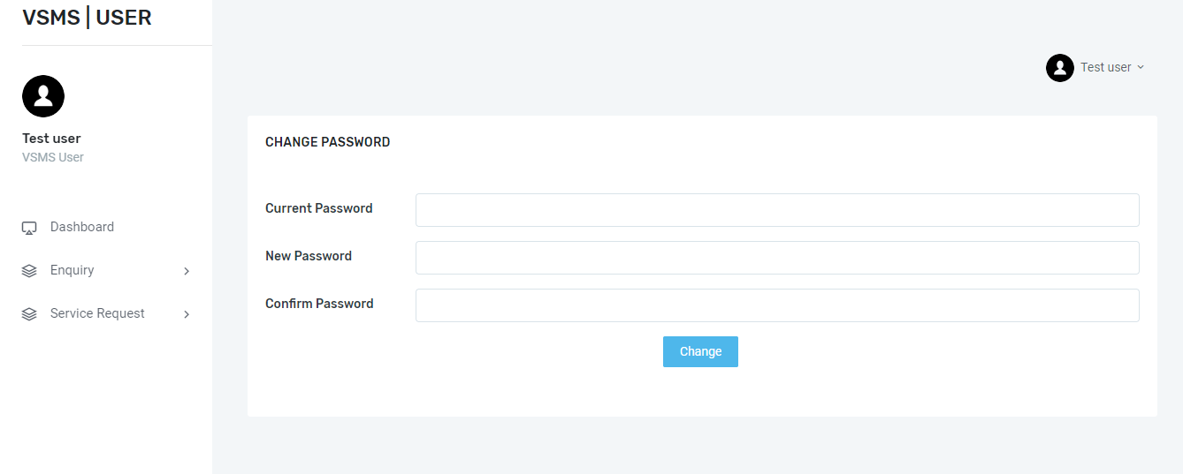

**User / Customer profile Page**

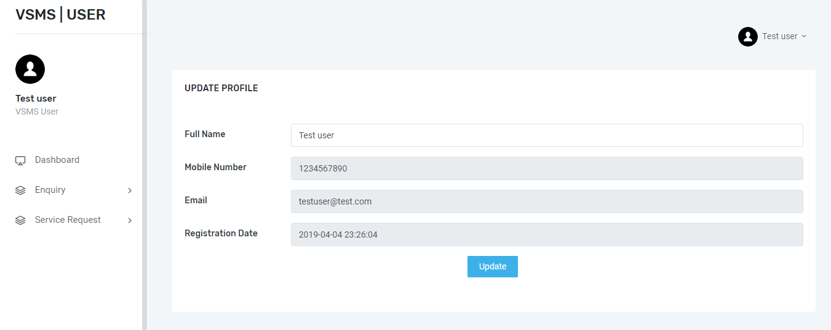

**User/ Customer Enquiry Page**

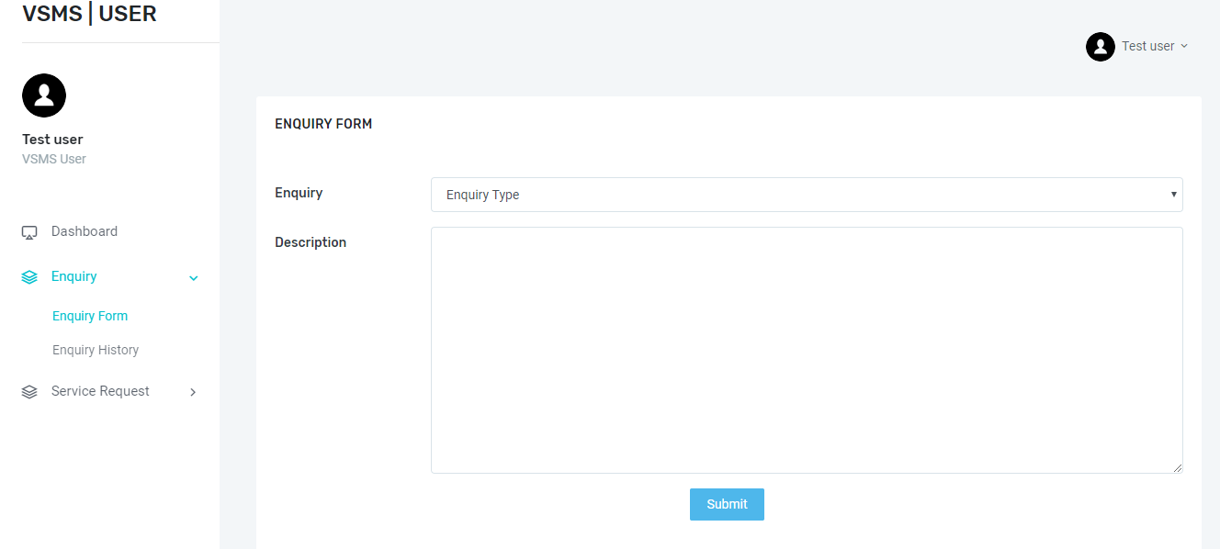

**Enquiry History Page**

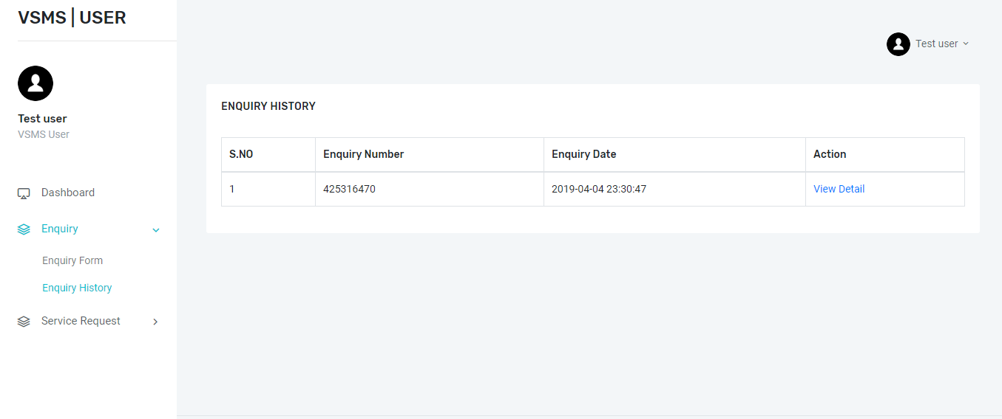

**Enquiry Details page**

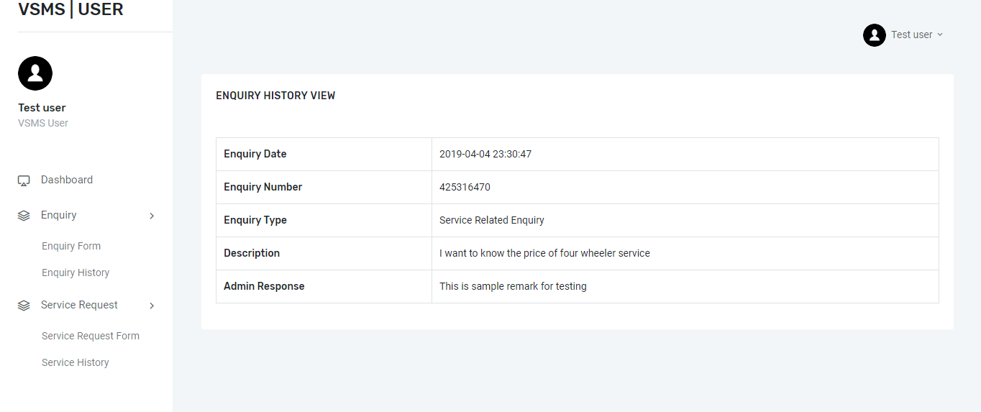

**User Car Service Request Page**

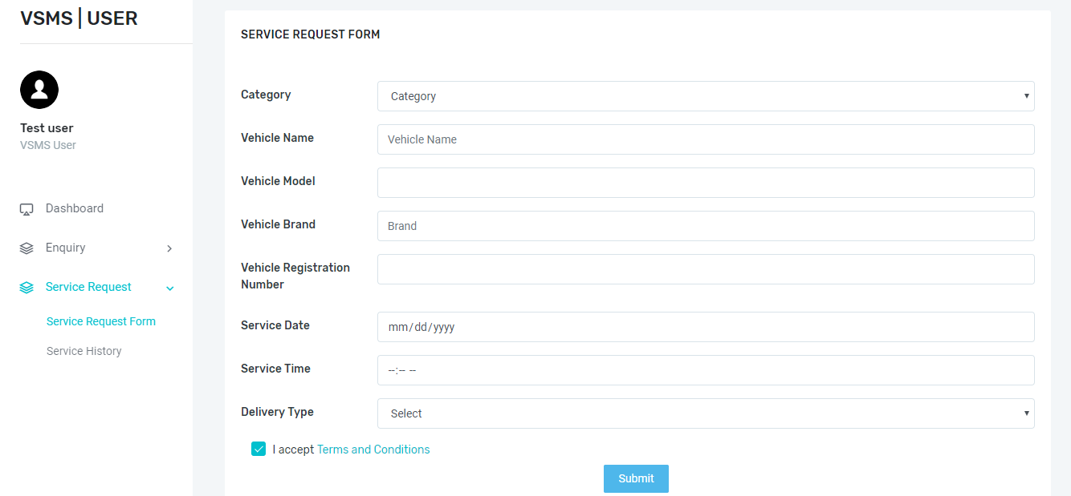

**Service History page**

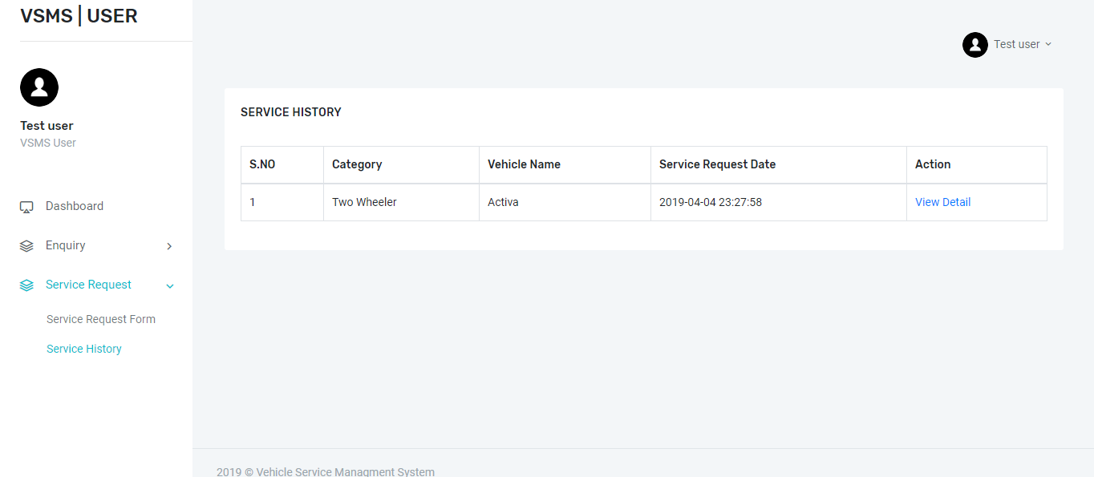

**Service Details Page**

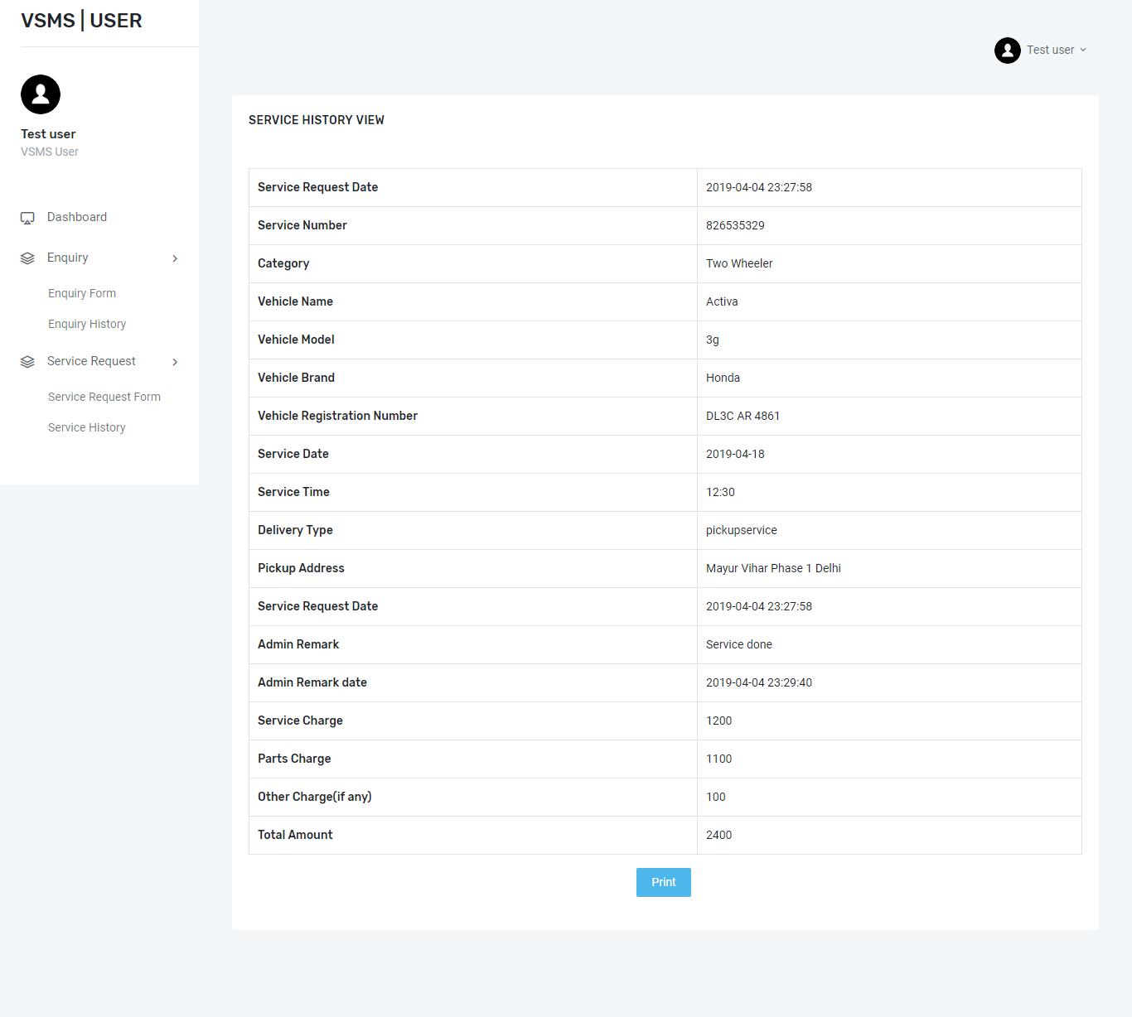

**Admin Login page**

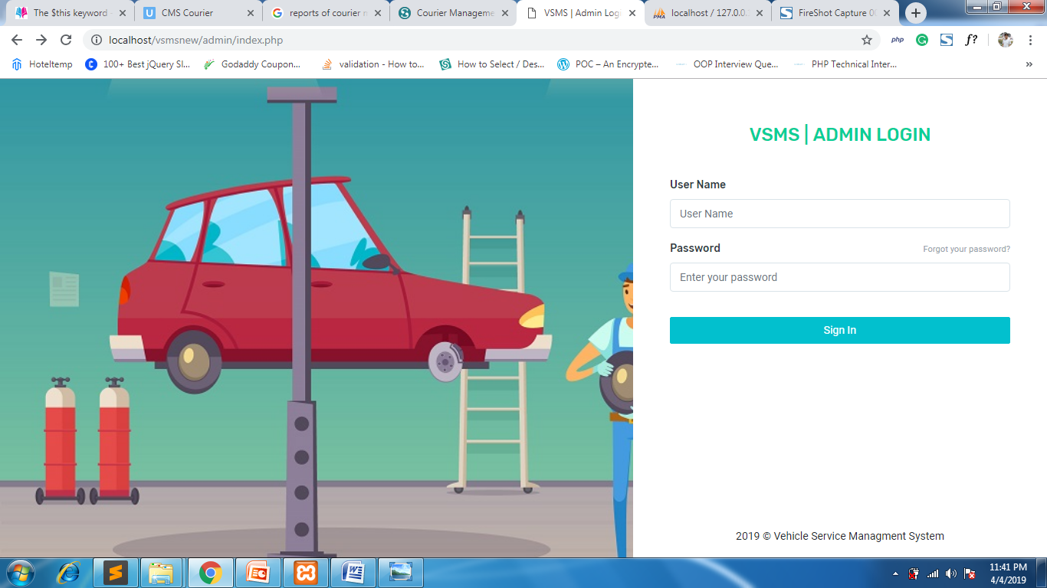

**Admin Password Recovery Page**

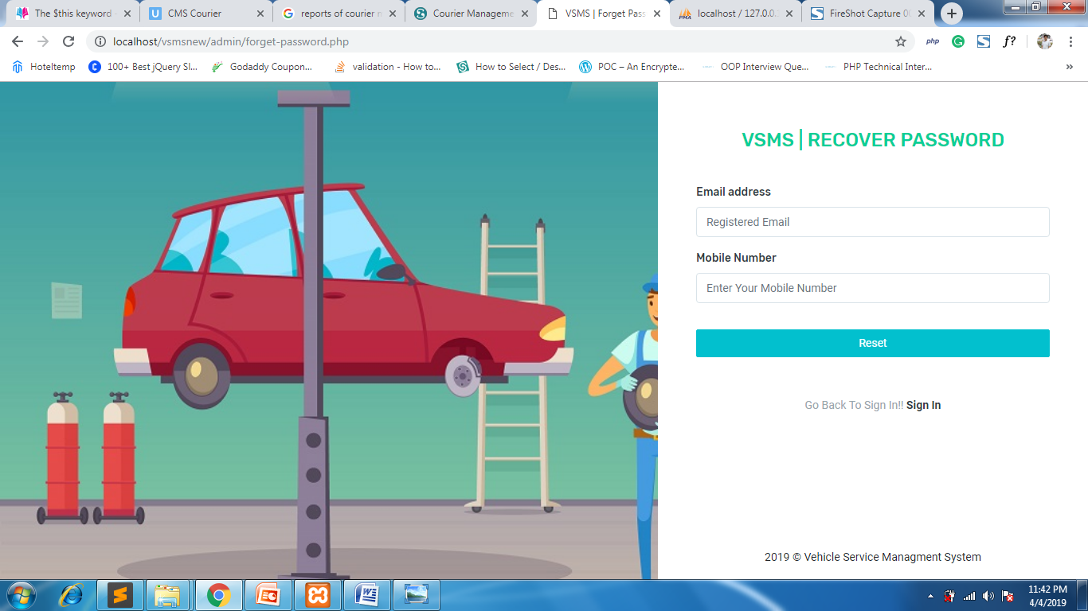

**Admin password Reset page**

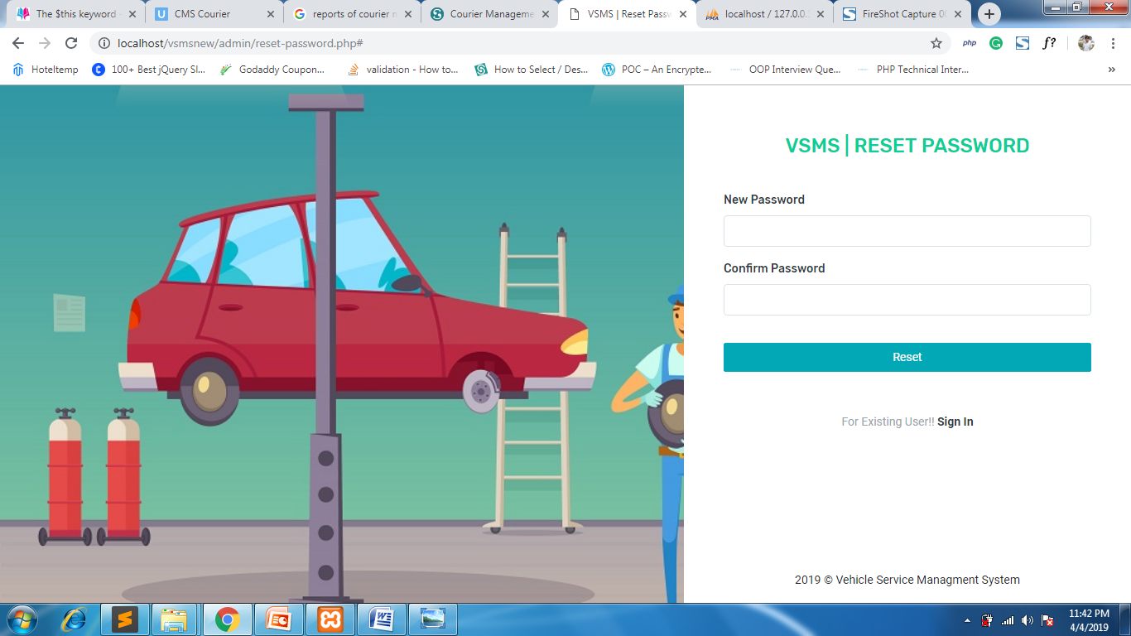

**Admin DashBoard**

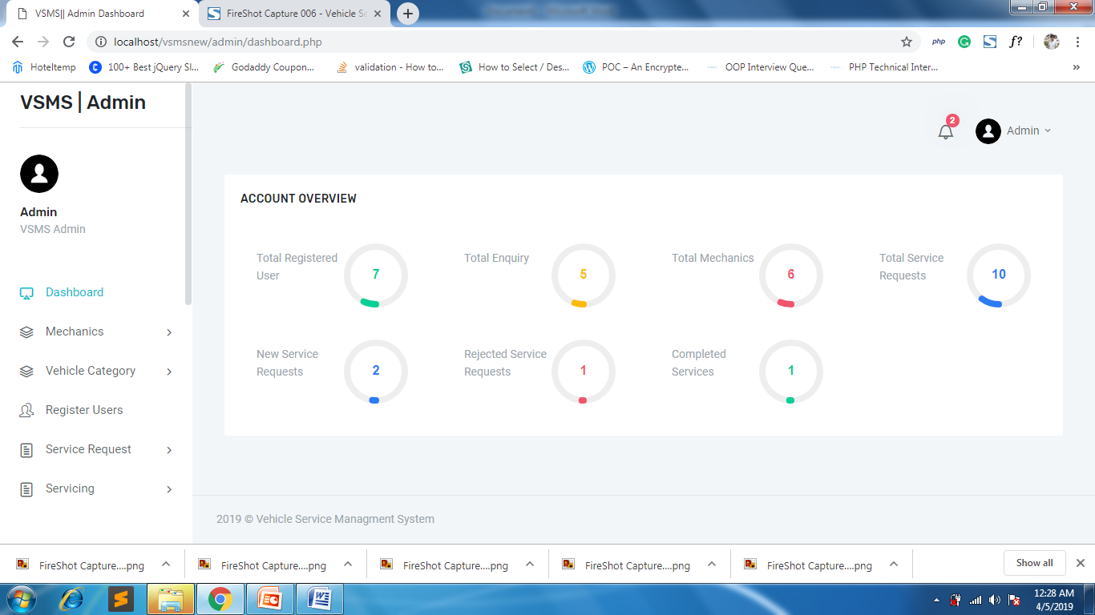

**Admin profile**

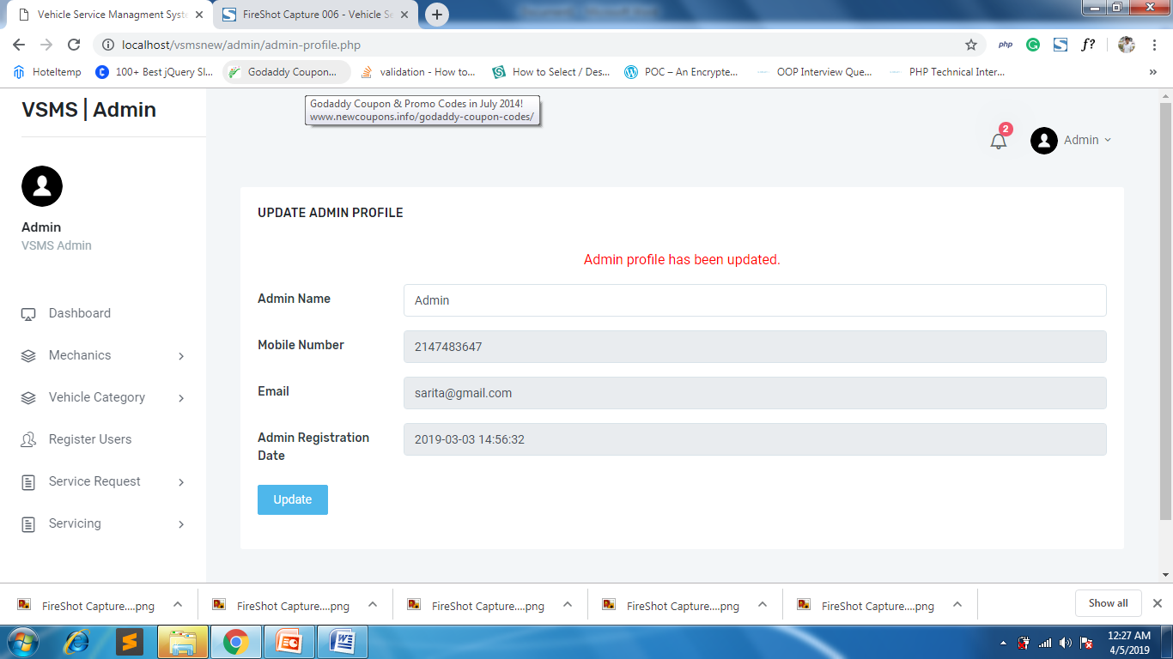

**Admin Change Password**

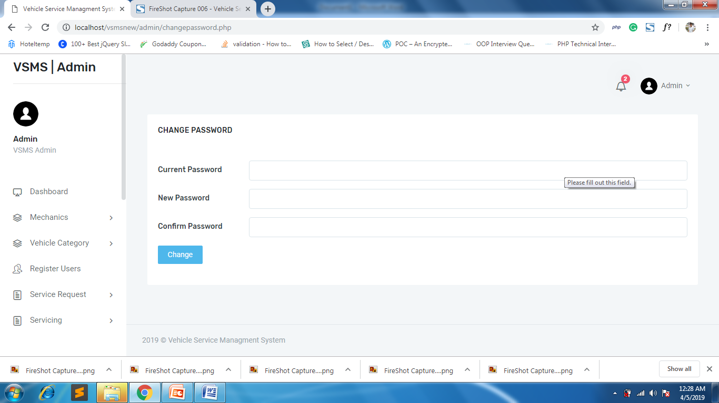

**Add Mechanic**

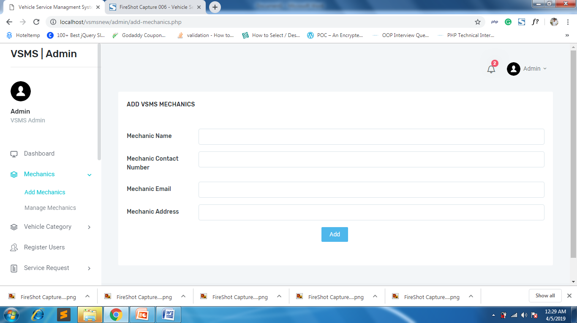

**Mechanics List**

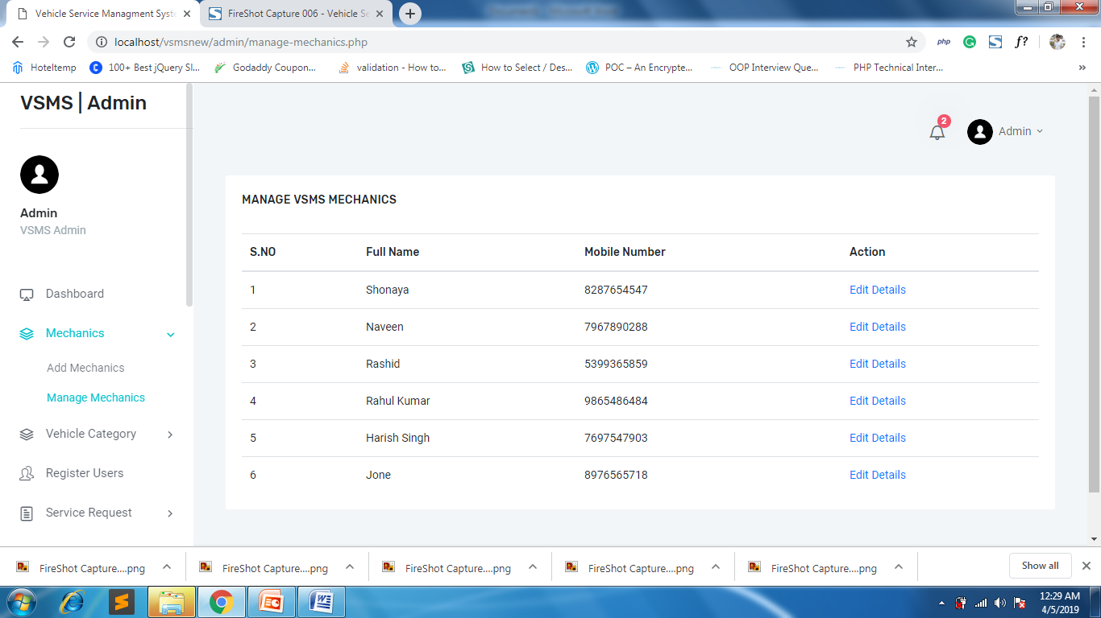

**Edit Mechanic Details**

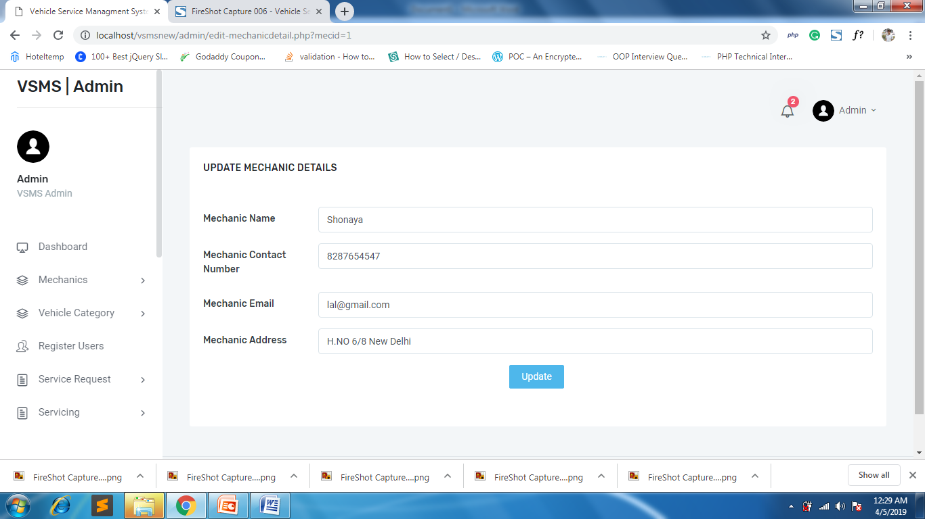

**Add Car Category**

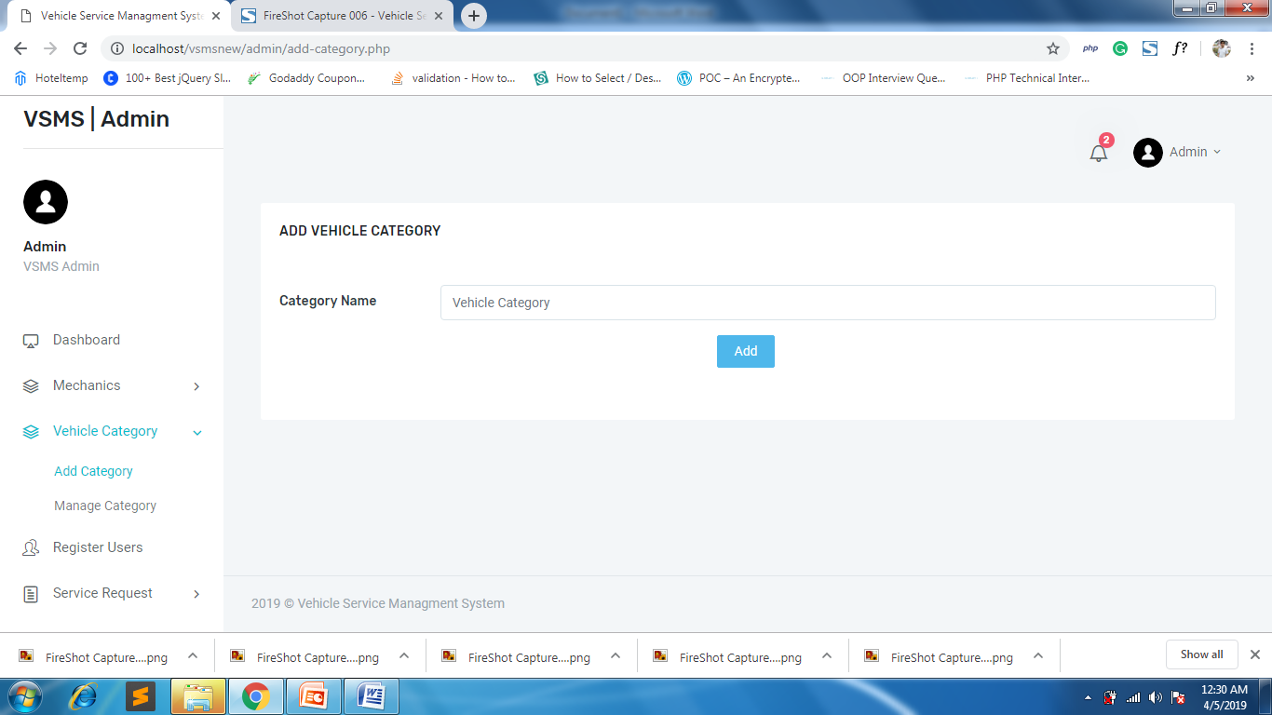

**Manage Car Categories**

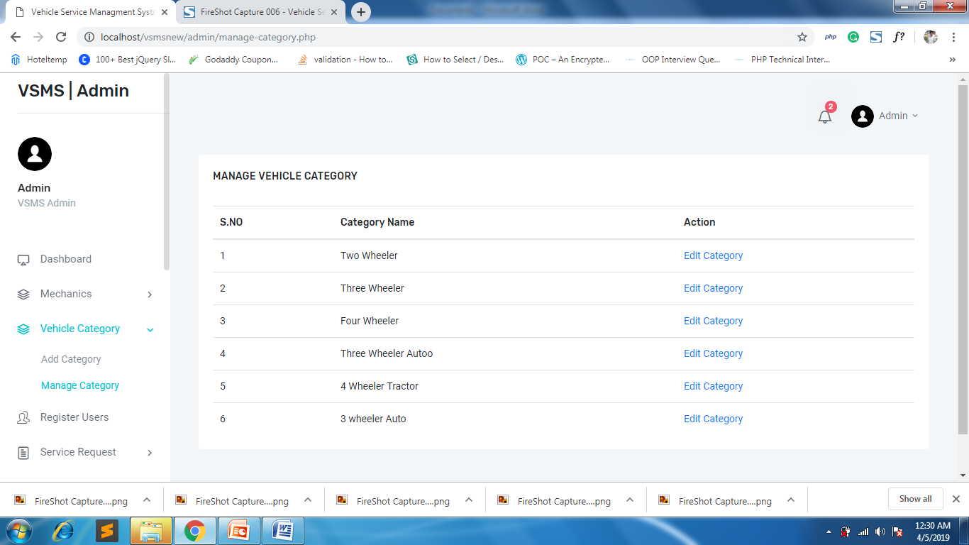

**Edit Category**

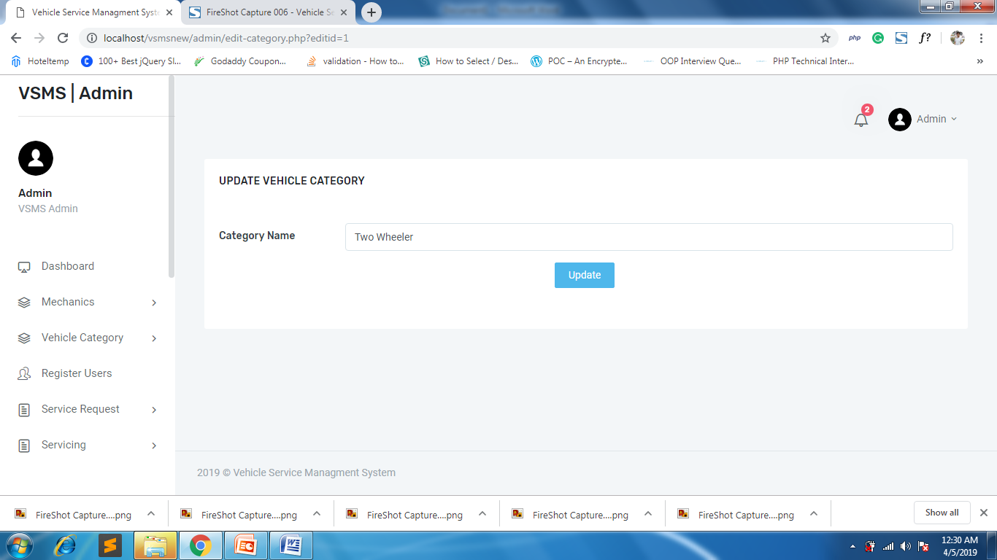

**Registered Users list**

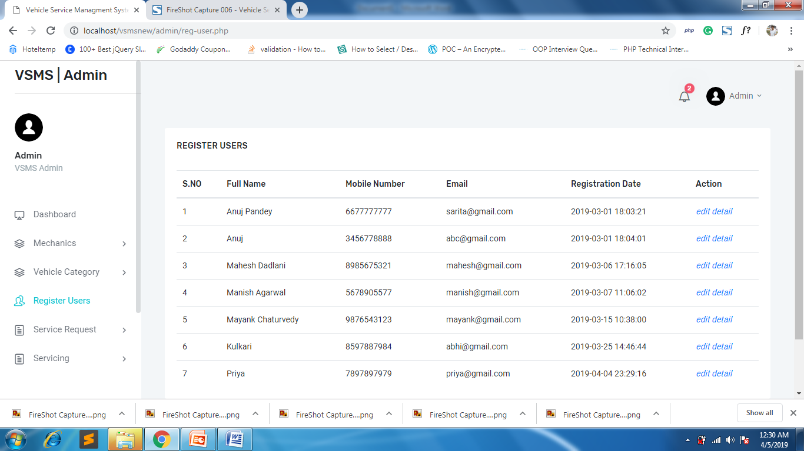

**Edit User Details**

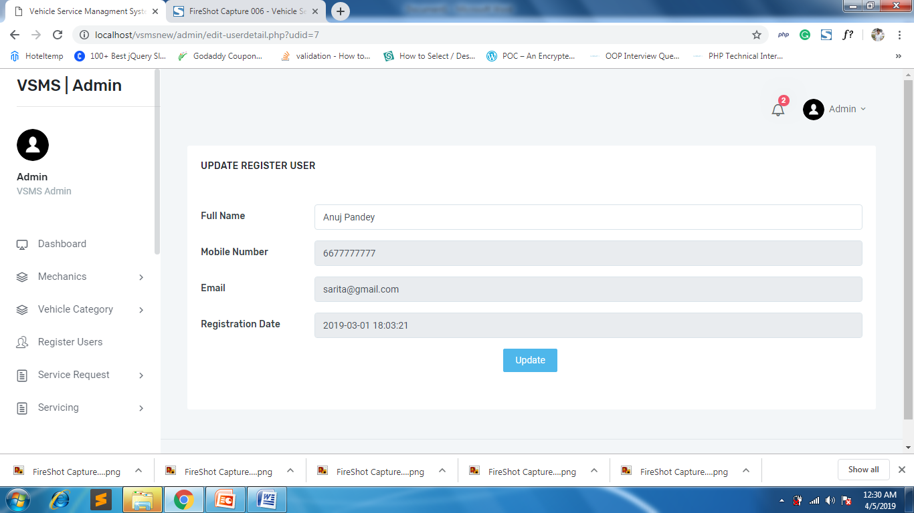

**Pending Service Requests**

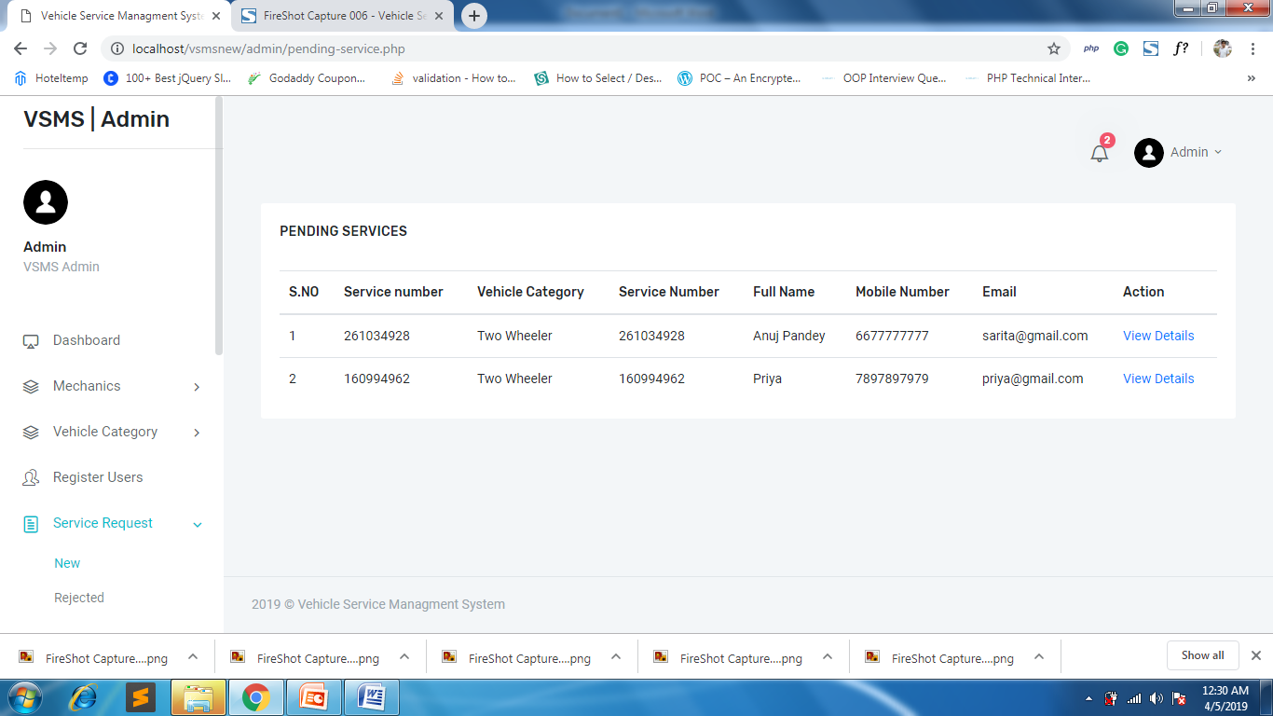

**View Pending Requests**

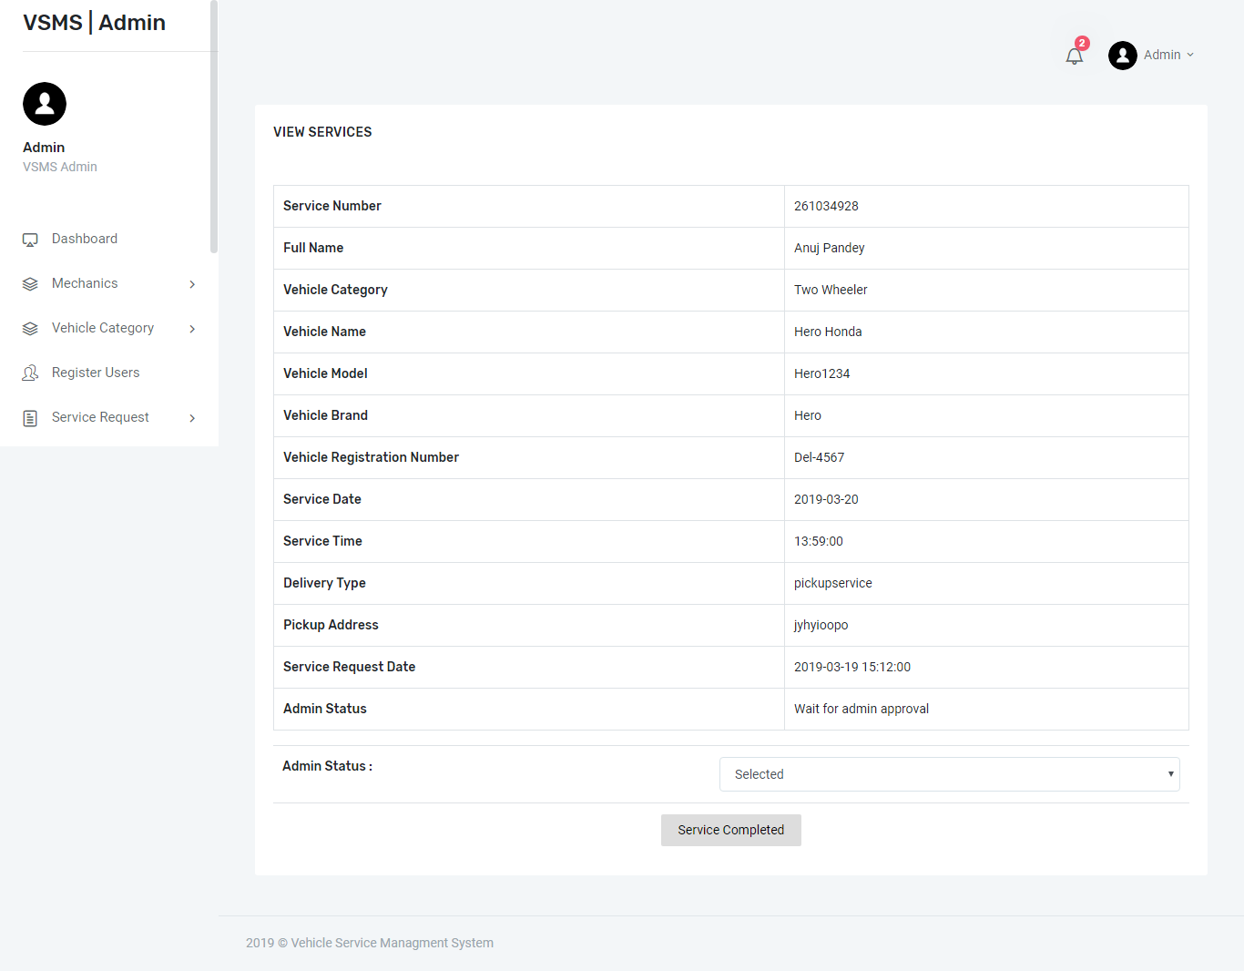

**Rejected Service Requests**

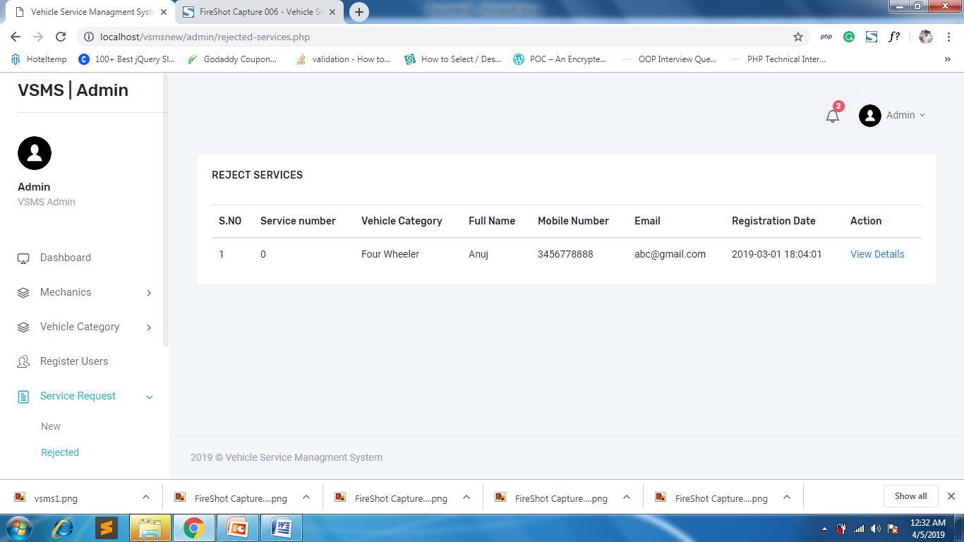

**Rejected service Details**

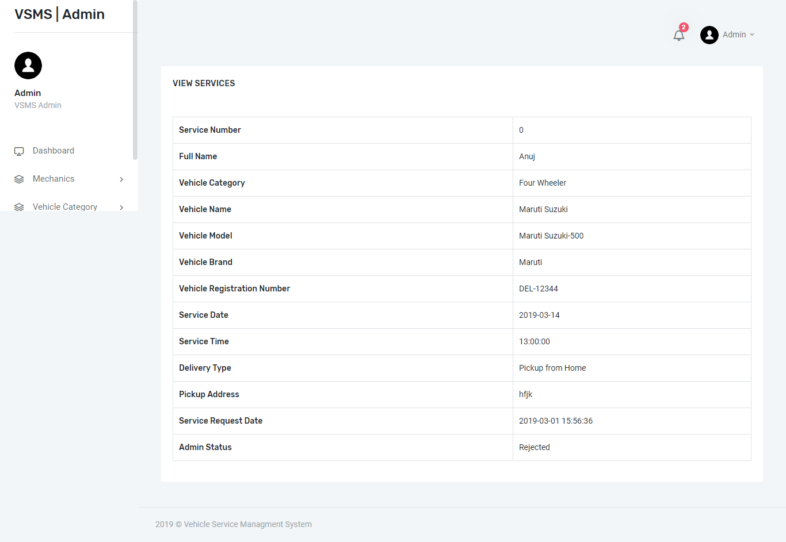

**Car Pending for Servicing**

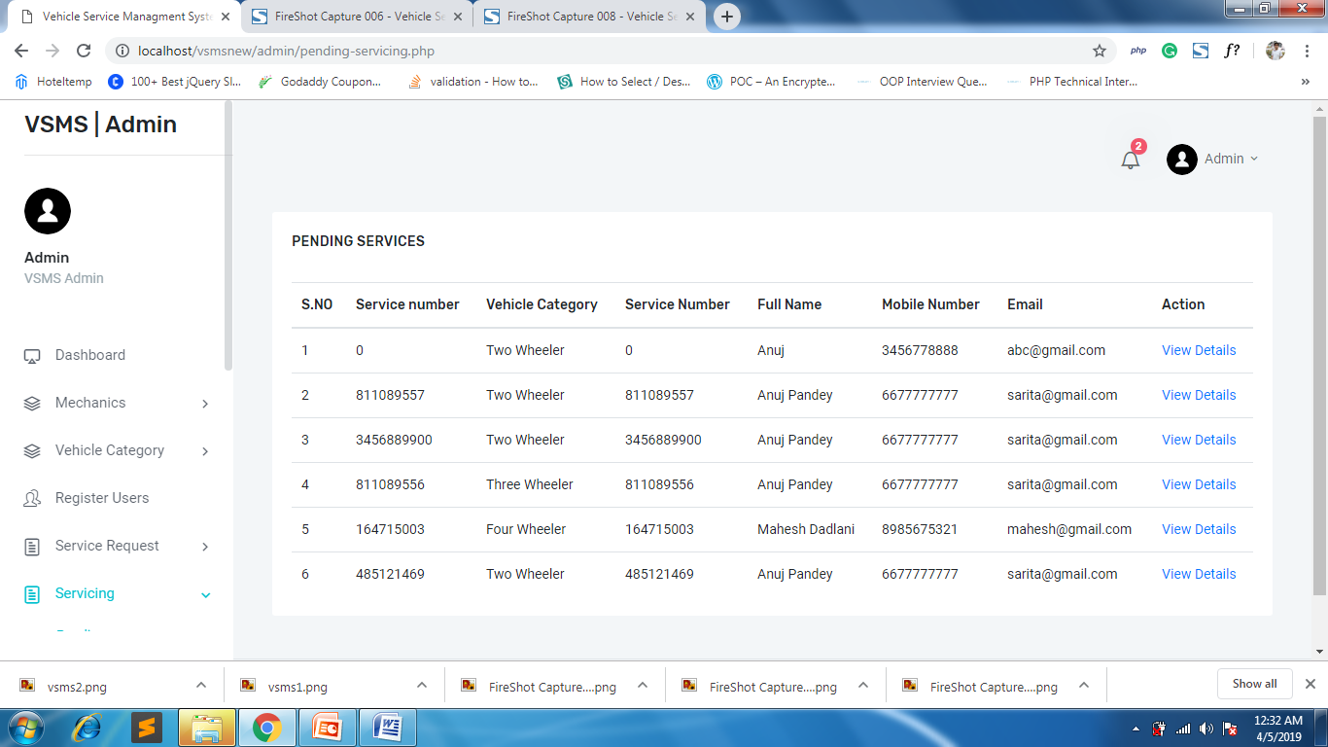

**Complete / Finished servicing page**

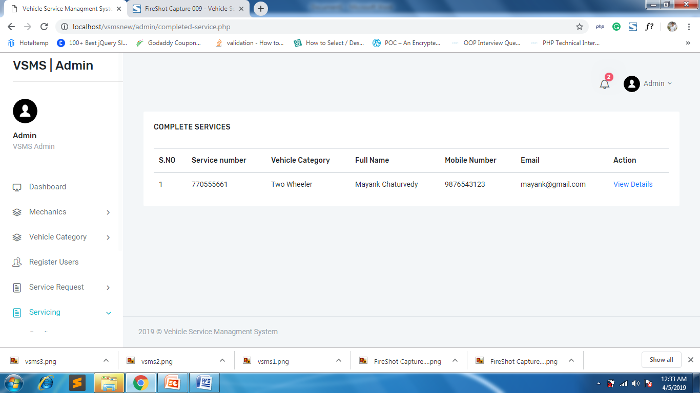

**Completed Car Serving Page**

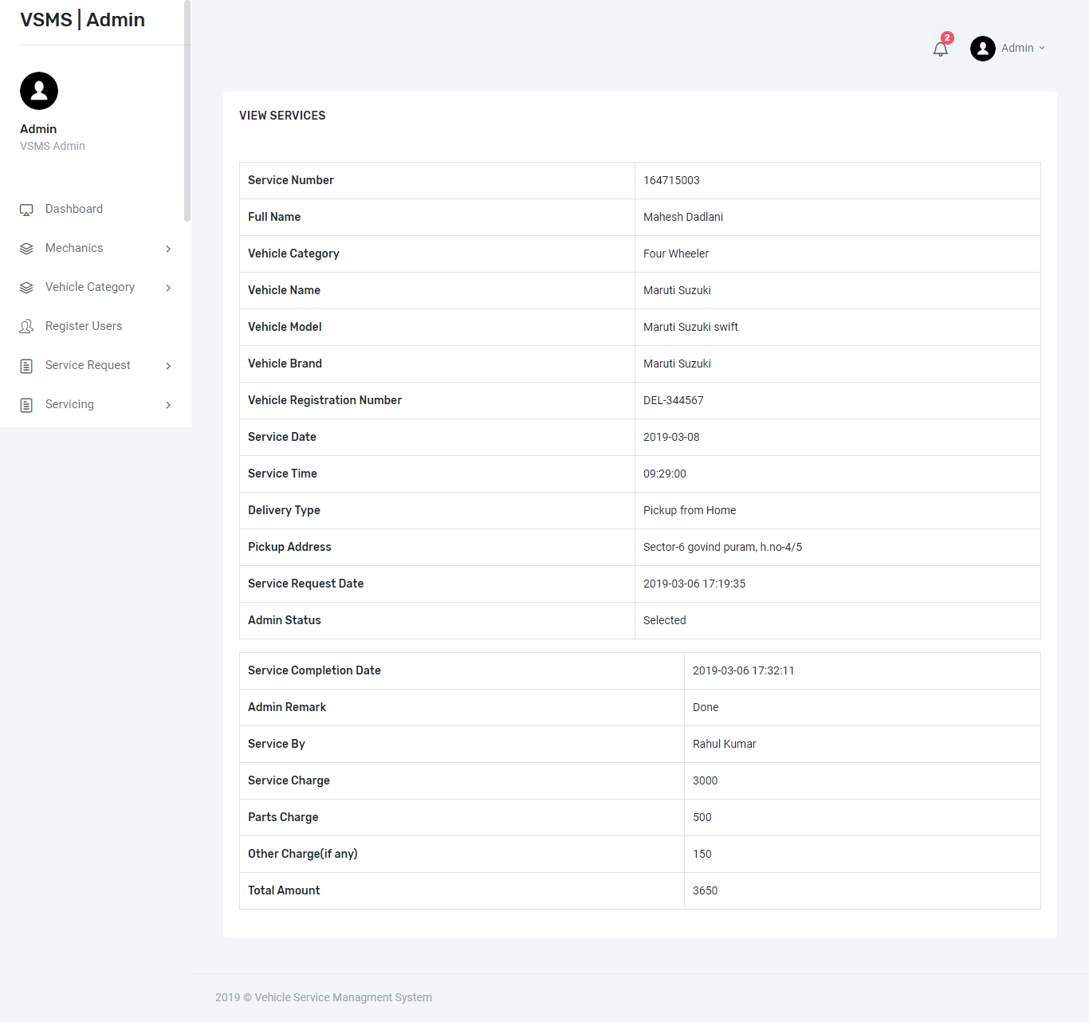

**Not Responded Queries Page**

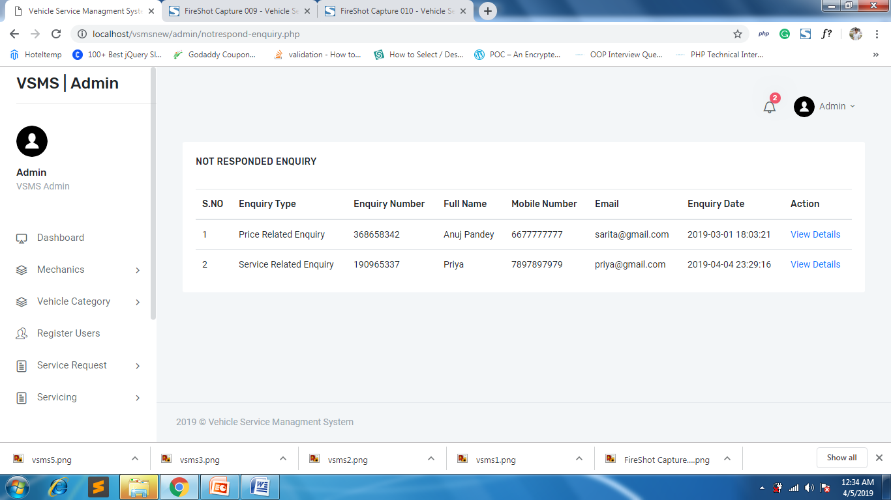

**View Enquiry Page**

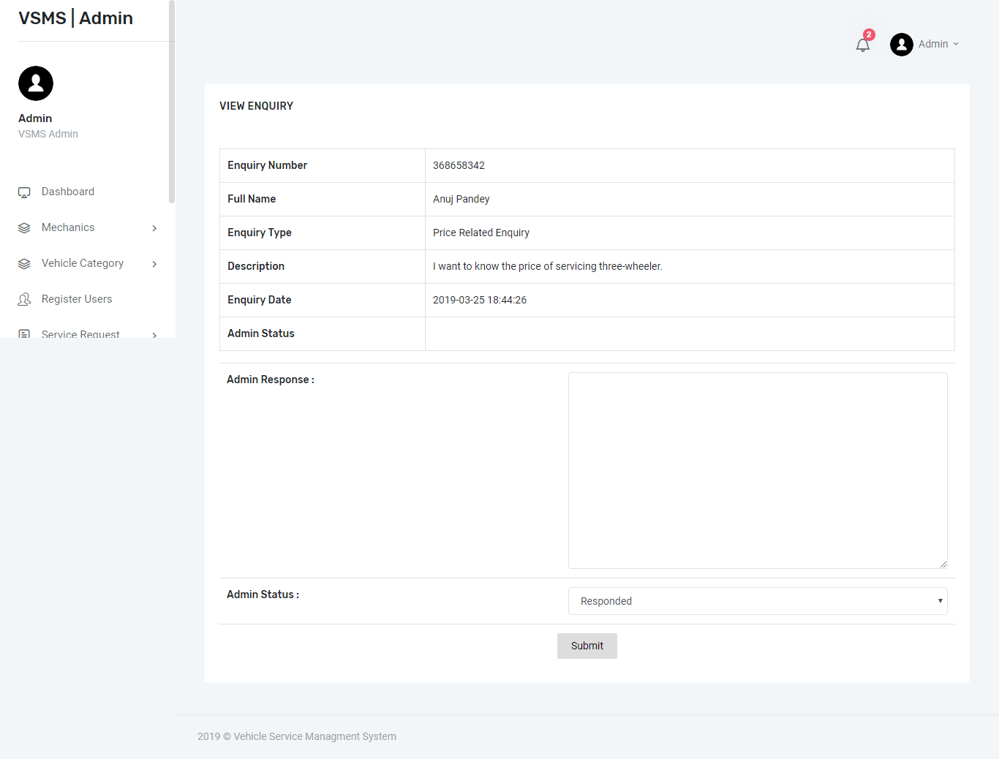

**Responded Enquiries**

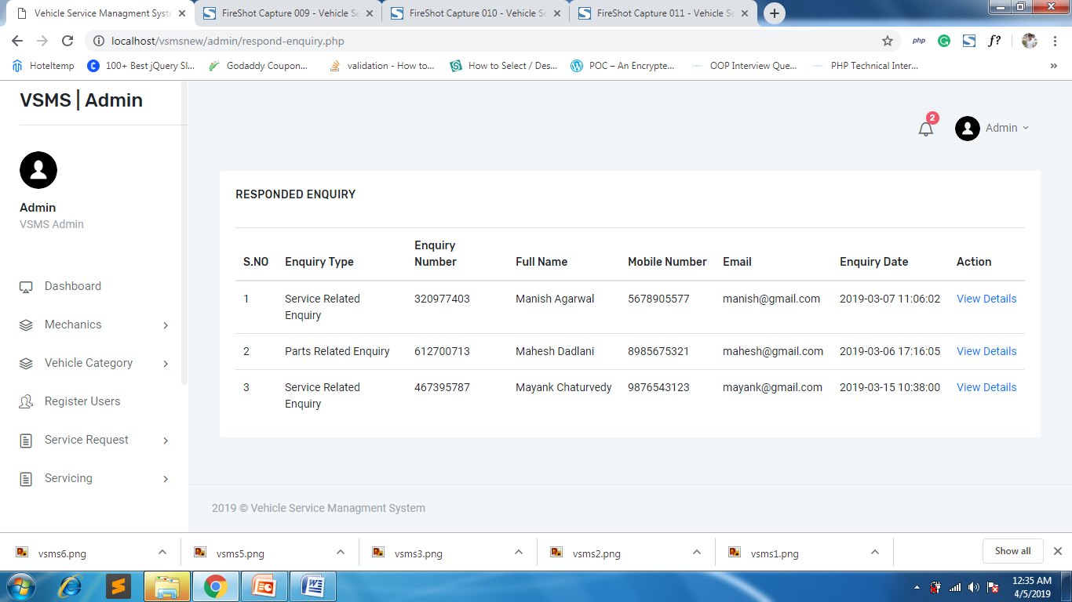

**View Enquiry Page with full details**

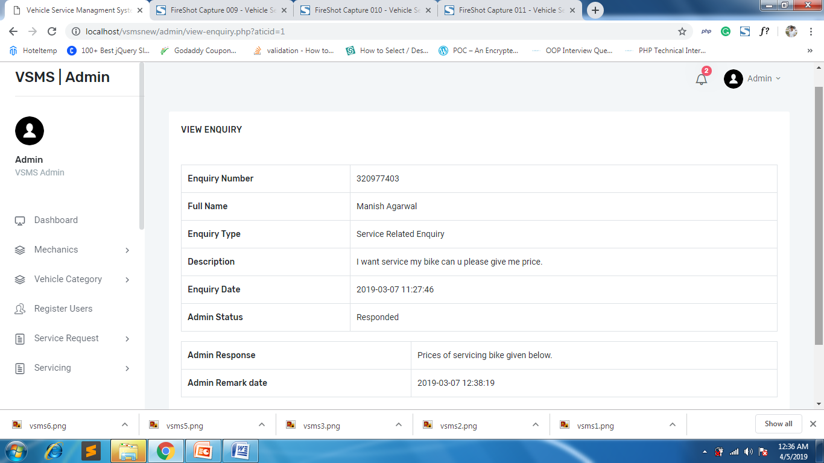

**Search Enquiry Page**

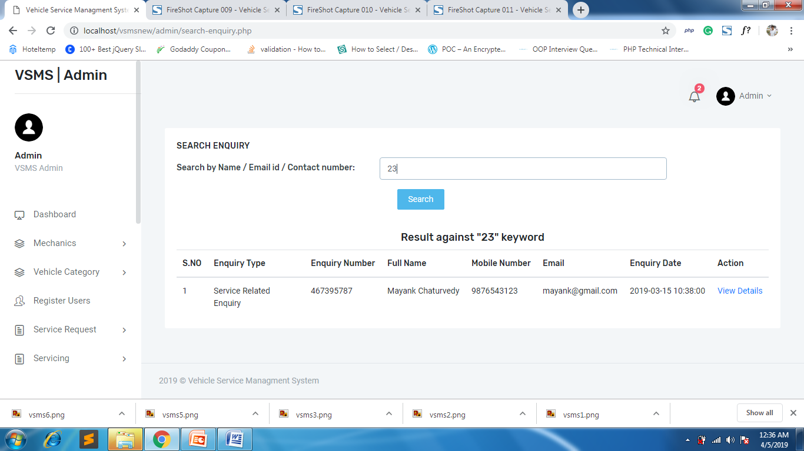

**Search Service Page**

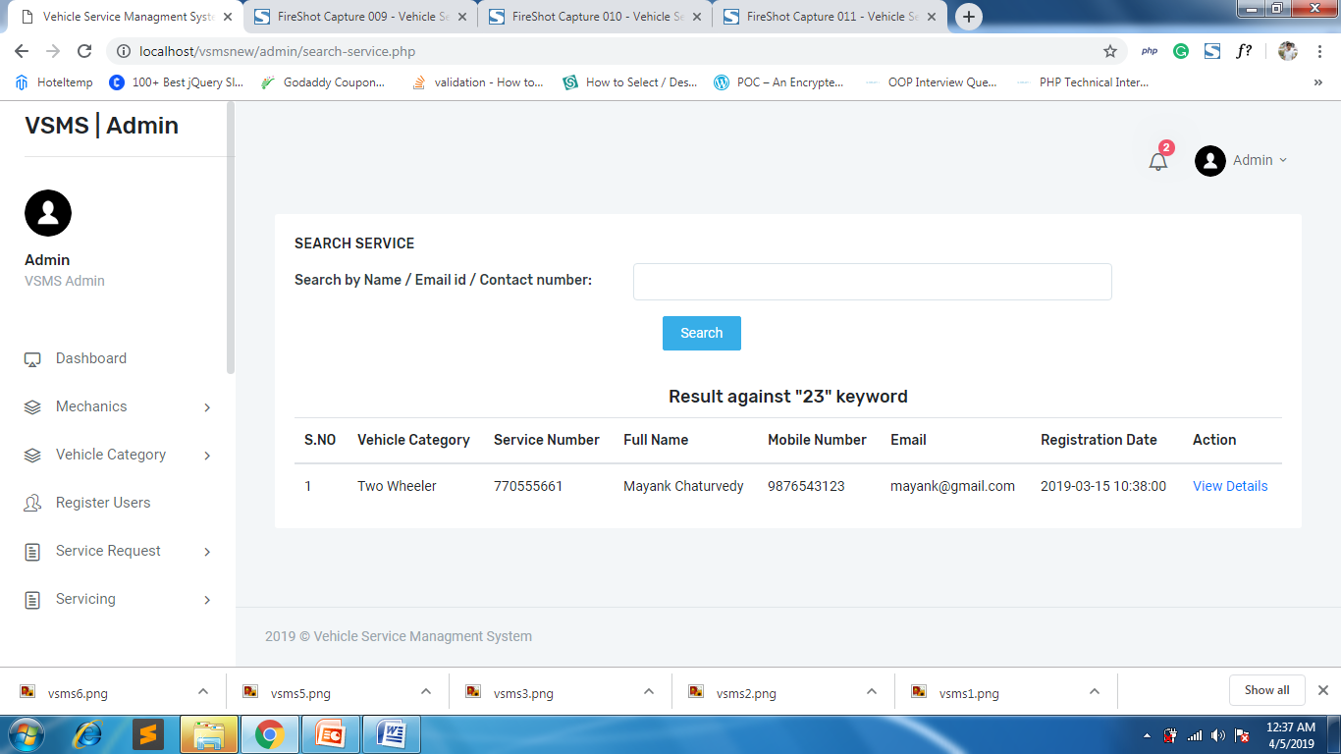

**CONCLUSION:**

The package was designed in such a way that future modifications can be done easily. The following conclusions can be deduced from the development of the project.

* + Automation of the entire system improves the efficiency
  + It provides a friendly graphical user interface which proves to be better when compared to the existing system.
  + It gives appropriate access to the authorized users depending on their permissions.
  + It effectively overcomes the delay in communications.
  + Updating of information becomes so easier.
  + System security, data security and reliability are the striking features.
  + The System has adequate scope for modification in future if it is necessary.

**References**

**For PHP**

* <https://www.w3schools.com/php/default.asp>
* <https://www.sitepoint.com/php/>
* <https://www.php.net/>

**For MySQL**

* <https://www.mysql.com/>
* [http://www.mysqltutorial.org](http://www.mysqltutorial.org/)

**For XAMPP**

* <https://www.apachefriends.org/download.html>